Software Requirements Specification (SRS) is one of the first phases of system development. This phase results in the Software Requirements Specification (SRS) document, which must contain a complete, concise, high-quality description of the system being considered.

Software Requirement Document- Infrastructure

**Sustainable Outreach And Universal**

**Leadership (SOUL) Limited**

Table of Content

A. Abstract 3

B. Introduction 3

Purpose 3

Scope 3

C. Definition, Acronyms and Abbreviations 3

D. Overview of the Document 3

E. Detailed requirement 3

F. Flowchart Description 3

G. Examination Flowchart 3

H. Overall Screens and Their Descriptions 3

1. Infrastructure Management 5

1.1. Land 5

1.2. Building 6

1.3. Floor 8

1.4. Building Room 10

1.5. Building type Room 12

1.6. Type of Residence 13

1.7. Residence Type 13

1.8. Application for Residence 15

1.9. Residence Allotment 16

1.10. Residence Allotted (Employee Child table) 18

1.11. Application for Residence De-Allottment 19

1.12. Residence De-Allottment 21

1.13. Residence Change Request (Workflow) 22

2. Infrastructure Project Management 22

2.1. Project 23

2.2. Task 26

2.3. Project Template 29

2.4. Project Type 30

2.5. Project Update 30

2.6. Timesheet 31

2.7. Activity Type 34

2.8. Activity Cost 35

3. Infrastructure Maintenance 36

# Abstract

Software Requirements Specification (SRS) is one of the first phases of system development. This phase results in the Software Requirements Specification (SRS) document, which must contain a complete, concise, high-quality description of the system being considered.

# Introduction

## **Purpose**

This document covers all the functional requirements of the Infrastructure module of ERP Product. The ERP Infrastructure module helps in organizing the entire

## **Scope**

The scope of this document are the features of the Infrastructure Module

1. Land, Buildings
2. Building Room
3. Application for Residence
4. Residence Allotment
5. Application for Residence De-Allotment
6. Residence De-Allotment
7. Residence Change request

# Definition, Acronyms and Abbreviations

The following table explains the terms and abbreviations used in the document

|  |  |
| --- | --- |
| **Abbreviation** | **Description** |
| SRS | Software Requirements Specification |
|  |  |
|  |  |
|  |  |

# Overview of the Document

This document presents the software requirements specifications of Infrastructure module.

# Detailed requirement

The system shall be available to and accessible by the following roles:

1. Building Administrator
2. Floor Supervisor
3. Maintenance Department

# Flowchart Description

# Examination Flowchart

# Overall Screens and Their Descriptions

The following tables lists the pages used in Infrastructure module :

|  |  |
| --- | --- |
| Existing Application Screen Name | Description |
| Land | This is a master screen which holds data regarding the land. Land here is in reference to the plot of land on which the building is built. |
| Building | This is a master screen for buildings. All the building information shall be stored here including documents like Building Letter(Records of right and Building design), Fire Approval, Electrical Inspection, etc. |
| Floor | The Floor Master Screen is a screen which will help the user to manage and track the layout of a building's floors and associated fixed assets. |
| Building Room | **This is a master screen, in which we shall be storing the building’s room details and classifying the rooms. This screen also help us assign a number to the residence** |
| Building type Room | **This screen helps define the type of the room, for example if it is a classroom or residential or conference hall.** |
| Type of Residence | **This screen helps in the classification of residence, whether it shall be a quarter or a duplex or even a villa.** |
| Residence Type | **This screen helps in further classification of residences in a building room based on types of residence. Example: 2BHK Quarter or 4BHK Villa and so on** |
| Project |  |
| Task |  |
| Project Template |  |
| Project Type |  |
| Project Update |  |
| Timesheet |  |
| Activity Type |  |
| Activity Cost |  |

# Infrastructure Management

## **Land**

**General Description**

|  |  |
| --- | --- |
| **Description** | This is a master screen which holds data regarding the land. Land here is in reference to the plot of land on which the building is built. The Land Master shall have attachment buttons for Allotment Letter and other documents.  Operations on this screen can be performed by the administrator only. |
| **Navigation** | Home > Infrastructure> Land |
| **Pre-requisites** |  |

**Screenshot**

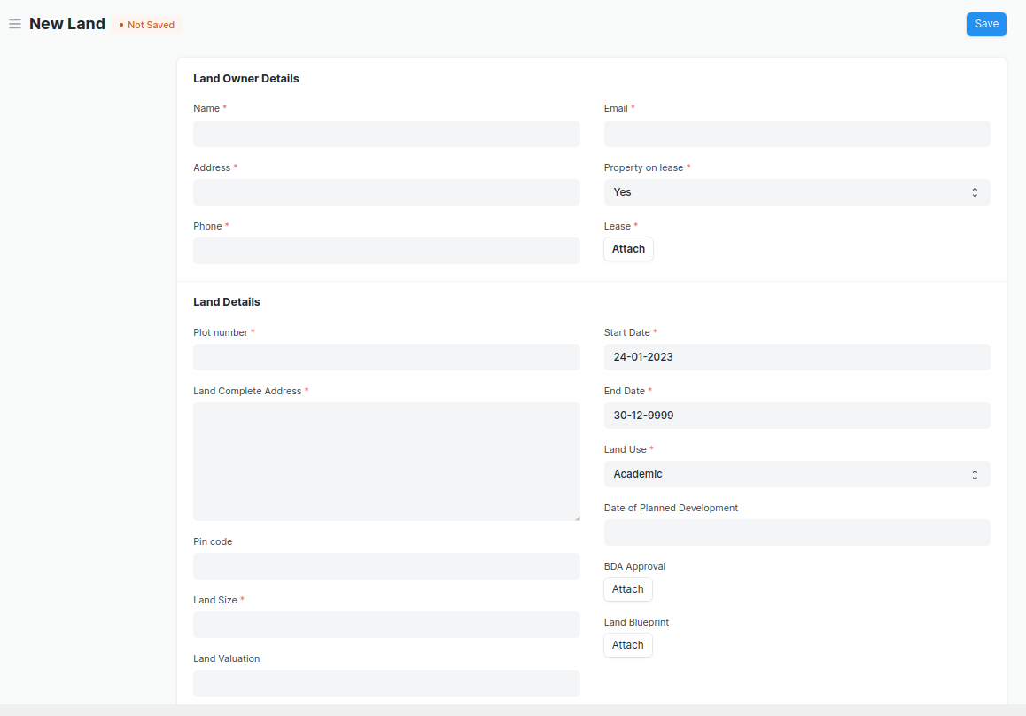

Figure 1: Land

**Field List**

The “Land” screen shall consist of the following fields:

|  |  |  |  |  |  |
| --- | --- | --- | --- | --- | --- |
| **ID** | **Field Label** | **Field Type** | **Validation/Action** | **Mandatory** | **Remarks** |
| **Land Owner Details** | | | | | |
| 1 | Name | Text Field |  | Y |  |
| 2 | Address | Text Field |  | Y |  |
| 3 | Phone | Text Field |  | Y |  |
| 4 | Email | Text Field |  | Y |  |
| 5 | Property on lease | Select | Yes  No | Y |  |
| 6 | Lease | Attach |  |  |  |
| **Land Details** | | | | | |
| 7 | Plot number | Data |  | Y |  |
| 8 | Land Complete Address | Small Text Field |  | Y |  |
| 9 | Pin code | Text Field |  |  |  |
| 10 | Land Size | Text Field |  | Y |  |
| 11 | Land Valuation | Currency |  |  |  |
| 12 | Start Date | Date |  | Y |  |
| 13 | End Date | Date |  | Y |  |
| 14 | Land Use | Drop down | Academic  Residential  Others | Y |  |
| 15 | Land Use, If others | Text Field |  | Display Depends on Land use drop down selection(others) |  |
| 16 | Date of Planned Development | Date |  |  |  |
| **Land Documents** | | | | | |
| **17** | **Land Documents** | Table |  |  |  |

|  |  |  |  |  |  |
| --- | --- | --- | --- | --- | --- |
| **Land Documents** | | | | | |
| **ID** | **Field Label** | **Field Type** | **Validation/Action** | **Mandatory** | **Remarks** |
| 1 | Document Name | Text Field | User Input |  |  |
| 2 | Document | Attach Button |  |  |  |

**User: Roles & Permission**

The following table describes the users and their roles and permissions for the screens:

|  |  |  |  |  |  |  |  |  |  |  |
| --- | --- | --- | --- | --- | --- | --- | --- | --- | --- | --- |
| **ID** | | **Role** | **Select** | **Read** | **Write** | **Create** | **Delete** | **Submit** | **Cancel** | **Amend** |
| 1 | Building Administrator | | Yes | Yes | Yes | Yes | Yes | NA | NA | NA |
| 2 | Floor Supervisor | | No | Yes | No | No | No | NA | NA | NA |
| 3 | Maintenance Department | | No | Yes | No | No | No | NA | NA | NA |
| 4 | Employee | |  |  |  |  |  |  |  |  |

## **Building**

**General Description**

|  |  |
| --- | --- |
| **Description** | This is a master screen for buildings. All the building information shall be stored here including documents like Building Letter(Records of right and Building design), Fire Approval, Electrical Inspection, etc. The buildings can be residential, academic or both. The actions on this screen can be performed by the administrator only. |
| **Navigation** | Home > Infrastructure> Building |
| **Pre-requisites** |  |

**Screenshot**

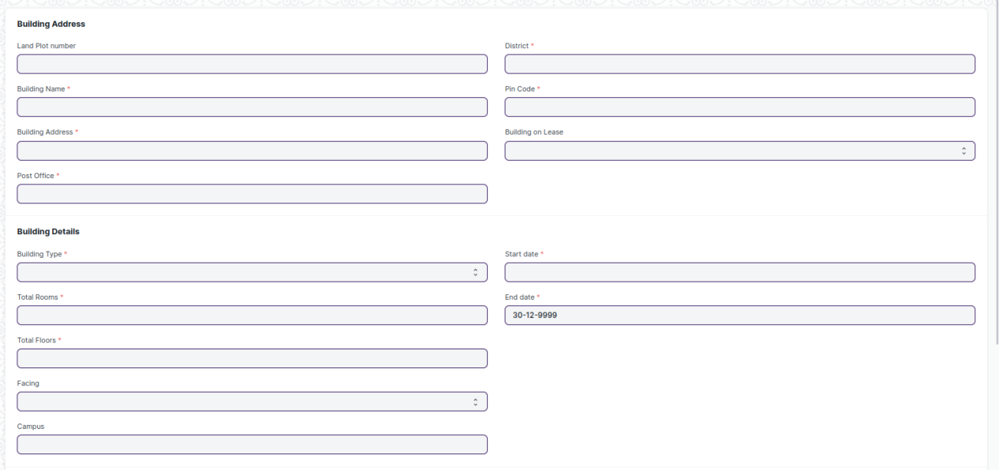

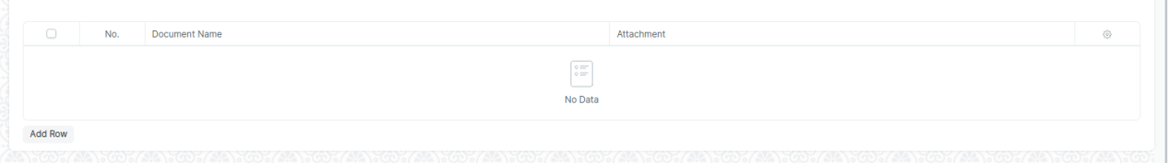

Figure 2: Building

**Field List**

The “Building” screen shall consist of the following fields:

|  |  |  |  |  |  |
| --- | --- | --- | --- | --- | --- |
| **ID** | **Field Label** | **Field Type** | **Validation/Action** | **Mandatory** | **Remarks** |
| **Building Address** | | | | | |
| 1 | Land Plot number | Link Field | Fetched from Land master screen |  |  |
| 2 | Land Address | Text Field | Auto fetch based on Land Plot Number |  |  |
| 3 | Building Name | Text Field | User Input | Y |  |
| 4 | Building Address | Text Field |  | Y |  |
| 5 | Post Office | Text Field |  | Y |  |
| 6 | District | Link Field | Districts | Y |  |
| 7 | State | Text Field |  | Y |  |
| 8 | Pin Code | Text Field |  | Y |  |
| **Building Details** | | | | | |
| 9 | Building on Lease | Drop down | Yes  No | Y |  |
| 10 | Lease | Attach | Display Depends on “Building on Lease” | Y |  |
| 11 | Building Type | Drop down | Academic  Administrative  Others | Y |  |
| 12 | Building Type, if any other | Text Field |  | Display Depends on “Building Type” drop down selection(others) |  |
| 13 | Total Rooms | Integer Field |  |  |  |
| 14 | Total Floors | Integer Field |  | Y |  |
| 15 | Facing | Drop down | North  South  East  West | Y |  |
| 16 | Campus | Text Field |  |  |  |
| 17 | Start date | Date picker |  |  |  |
| 18 | End date | Date picker |  |  |  |
| **Building Documents** | | | | | |
| **19** | **Building Documents** | Attach |  |  |  |

|  |  |  |  |  |  |
| --- | --- | --- | --- | --- | --- |
| **Building Documents** | | | | | |
| **ID** | **Field Label** | **Field Type** | **Validation/Action** | **Mandatory** | **Remarks** |
| 1 | Document Name | Text Field |  |  |  |
| 2 | Document | Attach Button |  |  |  |

**User: Roles & Permission**

The following table describes the users and their roles and permissions for the screens:

|  |  |  |  |  |  |  |  |  |  |
| --- | --- | --- | --- | --- | --- | --- | --- | --- | --- |
| **ID** | **Role** | **Select** | **Read** | **Write** | **Create** | **Delete** | **Submit** | **Cancel** | **Amend** |
| 1 | Building Administrator | Yes | Yes | Yes | Yes | Yes | NA | NA | NA |
| 2 | Floor Supervisor | No | Yes | No | No | No | NA | NA | NA |
| 3 | Maintenance Department | No | Yes | No | No | No | NA | NA | NA |
| 4 | Employee |  |  |  |  |  |  |  |  |

## **Floor**

**General Description**

|  |  |
| --- | --- |
| **Description** | * The Floor Master Screen is a screen which will help the user to manage and track the layout of a building's floors and associated fixed assets. It provides an interface that allows users to view floor plans, assign fixed assets to specific locations, and record important maintenance information. * One of the key features of the Floor Master Screen is the ability to upload layout drawings, which can be used as a reference for future maintenance and planning. This feature allows users to quickly identify the location of specific assets or areas within the building, which can save time and reduce the risk of errors. * The Floor Master Screen allows users to record floor-wise details, such as assigning non-movable assets to specific locations. The application keeps this information in MM, but users can access it through the Infrastructure. This allows users to easily view the details of each floor and the assets assigned to it. |
| **Navigation** | Home > Infrastructure> Floor |
| **Pre-requisites** |  |

**Field List**

The “Floor” screen shall consist of the following fields:

|  |  |  |  |  |  |
| --- | --- | --- | --- | --- | --- |
| **ID** | **Field Label** | **Field Type** | **Validation/Action** | **Mandatory** | **Remarks** |
| **Floor Details** | | | | | |
| 1 | Building Name | Link Field | Fetched from Building master screen | Y |  |
| 2 | Floor Number | Text Field |  | Y |  |
| 3 | Floor Size | Integer Field |  |  |  |
| 4 | Number of rooms | Text Field |  | Y |  |
| 5 | Floor Plan | Attach |  |  |  |
| 6 | Floor Incharge | Text Field |  |  |  |
| **Asset Details** | | | | | |
| **7** | **Floor Assets** | Table |  |  |  |

|  |  |  |  |  |  |
| --- | --- | --- | --- | --- | --- |
| **Floor Assets** | | | | | |
| **ID** | **Field Label** | **Field Type** | **Validation/Action** | **Mandatory** | **Remarks** |
| 1 | Item Code | Link Field | Fetched from Item master screen | Y |  |
| 2 | Item Name | Text Field | Auto fetch based on Item Code |  |  |
| 3 | Location | Link Field | Fetched from Location master screen |  |  |
| 4 | Asset Name | Text Field | User Input |  |  |
| 5 | Custodian | Link Field | Fetched from Employee master screen | Y |  |
| 6 | Department | Link Field | Fetched from Department screen | Y |  |

**User: Roles & Permission**

The following table describes the users and their roles and permissions for the screens:

|  |  |  |  |  |  |  |  |  |  |
| --- | --- | --- | --- | --- | --- | --- | --- | --- | --- |
| **ID** | **Role** | **Select** | **Read** | **Write** | **Create** | **Delete** | **Submit** | **Cancel** | **Amend** |
| 1 |  | Yes | Yes | Yes | Yes | Yes | NA | NA | NA |
| 2 |  | No | Yes | No | No | No | NA | NA | NA |
| 3 |  | No | Yes | No | No | No | NA | NA | NA |
| 4 |  |  |  |  |  |  |  |  |  |

## **Building Room**

**General Description**

|  |  |
| --- | --- |
| **Description** | **This is a master screen, in which we shall be storing the building’s room details and classifying the rooms. This screen also help us assign a number to the residence ( For e.g, Residence number).**  **The operations on this screen can be performed by the Administrator only.**  **In this screen, the user shall select the type of room and, based on selection, the type of residence shall be fetched.**  **Further on selection of type of residence, the residence type name(e.g. 2BHK) drop down shall be fetched.** |
| **Navigation** | Home > Infrastructure> Building Room |
| **Pre-requisites** |  |

**Screenshot**

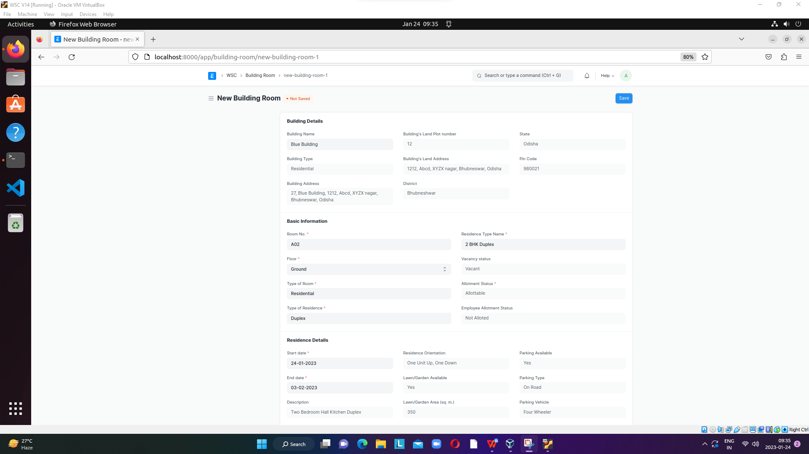

Figure 3

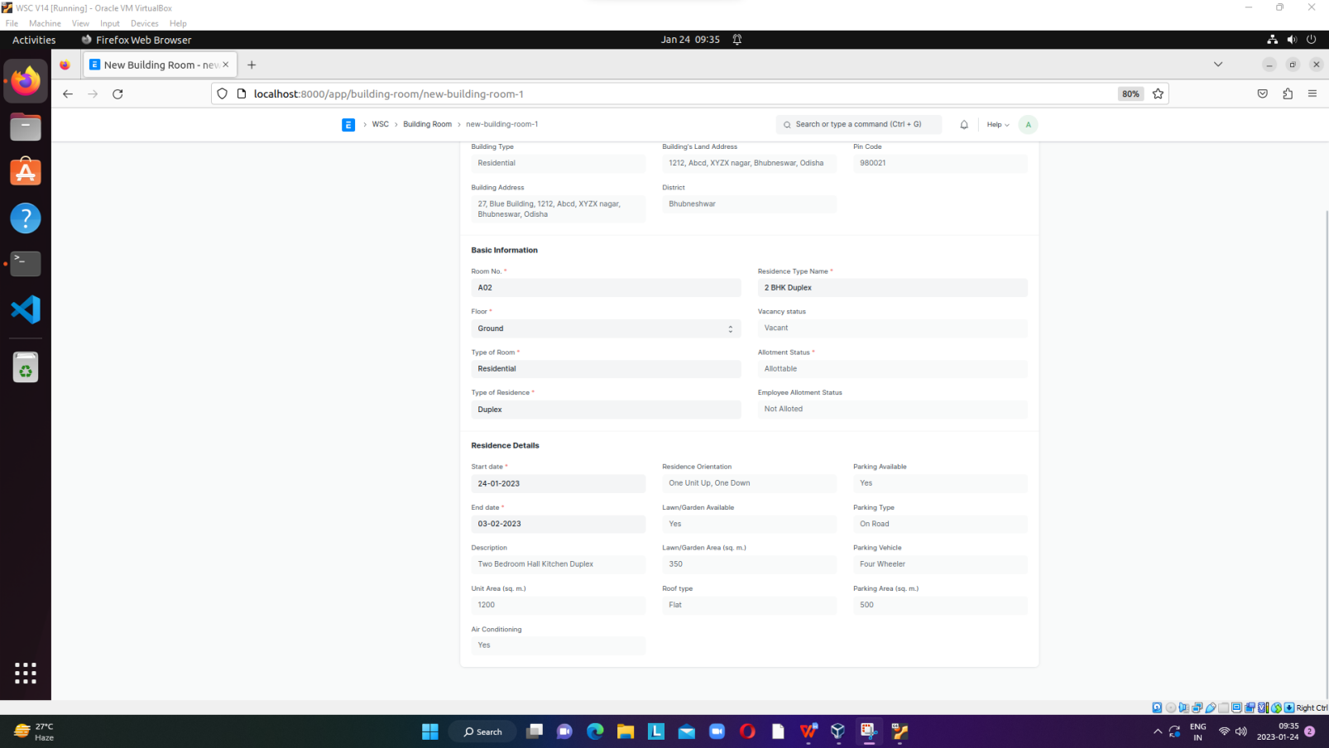

**Field List**

The **“Building Room**” screen shall consist of the following fields:

|  |  |  |  |  |  |
| --- | --- | --- | --- | --- | --- |
| **ID** | **Field Label** | **Field Type** | **Validation/Action** | **Mandatory** | **Remarks** |
| **Building Details** | | | | | |
| 1 | Building Name | Link | Buildings |  |  |
| 2 | Building Type | Data |  |  |  |
| 3 | Building Address | Data |  | Y |  |
| 4 | Building's Land Plot number | Data |  | Y |  |
| 5 | Building's Land Address | Data |  | Y |  |
| 6 | District | Data |  | Y |  |
| 7 | State | Data |  | Y |  |
| 8 | Pin Code | Data |  | Y |  |
| **Basic Information** | | | | | |
| 9 | Room No. | Data |  | Y |  |
| 10 | Floor | Data | Ground  1 ….. |  |  |
| 11 | Type of Room | Link | Building type Room | Y |  |
| 12 | Type of Residence | Link | Type of Residence | Y |  |
| 13 | Residence Type Name | Link | Residence Type | Y |  |
| 14 | Vacancy status | Drop down | Vacant  Not Vacant |  |  |
| 15 | Allotment Status | Data |  |  |  |
| 16 | Employee Allotment Status | Data |  |  |  |
| **Residence Details** | | | | | |
| 17 | Start date | Date | Start date cant be grater than the end date |  |  |
| 18 | End date | Date | End date cant be |  |  |
| 19 | Description | Data |  |  |  |
| 20 | Unit Area (sq. m.) | Data |  |  |  |
| 21 | Air Conditioning | Data |  |  |  |
| 22 | Residence Orientation | Data |  |  |  |
| 23 | Lawn/Garden Available | Data |  |  |  |
| 24 | Lawn/Garden Area (sq. m.) | Data |  |  |  |
| 25 | Roof type | Data |  |  |  |
| 26 | Parking Available | Data |  |  |  |
| 27 | Parking Type | Data |  |  |  |
| 28 | Parking Vehicle | Data |  |  |  |
| 29 | Parking Area (sq. m.) | Data |  |  |  |

**User: Roles & Permission**

The following table describes the users and their roles and permissions for the screens:

|  |  |  |  |  |  |  |  |  |  |
| --- | --- | --- | --- | --- | --- | --- | --- | --- | --- |
| **ID** | **Role** | **Select** | **Read** | **Write** | **Create** | **Delete** | **Submit** | **Cancel** | **Amend** |
| 1 |  | Yes | Yes | Yes | Yes | Yes | NA | NA | NA |
| 2 |  | No | Yes | No | No | No | NA | NA | NA |
| 3 |  | No | Yes | No | No | No | NA | NA | NA |
| 4 |  |  |  |  |  |  |  |  |  |

## **Building type Room**

**General Description**

|  |  |
| --- | --- |
| **Description** | **This screen helps define the type of the room, for example if it is a classroom or residential or conference hall. The operations on this screen can be performed by the Administrator only.** |
| **Navigation** | Home > Infrastructure> Building Type Room |
| **Pre-requisites** |  |

**Field List**

The **“Building Type Room**” screen shall consist of the following fields:

|  |  |  |  |  |  |
| --- | --- | --- | --- | --- | --- |
| **ID** | **Field Label** | **Field Type** | **Validation/Action** | **Mandatory** | **Remarks** |
| 1 | Type of Room | Data |  | Y |  |
| 2 | Allotment Status | Drop down | Allottable  Non Allottable | Y |  |

**User: Roles & Permission**

The following table describes the users and their roles and permissions for the screens:

|  |  |  |  |  |  |  |  |  |  |
| --- | --- | --- | --- | --- | --- | --- | --- | --- | --- |
| **ID** | **Role** | **Select** | **Read** | **Write** | **Create** | **Delete** | **Submit** | **Cancel** | **Amend** |
| 1 |  | Yes | Yes | Yes | Yes | Yes | NA | NA | NA |
| 2 |  | No | Yes | No | No | No | NA | NA | NA |
| 3 |  | No | Yes | No | No | No | NA | NA | NA |
| 4 |  |  |  |  |  |  |  |  |  |

## **Type of Residence**

**General Description**

|  |  |
| --- | --- |
| **Description** | **This screen helps in the classification of residence, whether it shall be a quarter or a duplex or even a villa. The operations on this screen can be performed by the Administrator only.** |
| **Navigation** | Home > Infrastructure> Type of Residence |
| **Pre-requisites** |  |

**Field List**

The **“Type of Residence**” screen shall consist of the following fields:

|  |  |  |  |  |  |
| --- | --- | --- | --- | --- | --- |
| **ID** | **Field Label** | **Field Type** | **Validation/Action** | **Mandatory** | **Remarks** |
| 1 | Type of Residence | Data |  | Y |  |

**User: Roles & Permission**

The following table describes the users and their roles and permissions for the screens:

|  |  |  |  |  |  |  |  |  |  |
| --- | --- | --- | --- | --- | --- | --- | --- | --- | --- |
| **ID** | **Role** | **Select** | **Read** | **Write** | **Create** | **Delete** | **Submit** | **Cancel** | **Amend** |
| 1 |  | Yes | Yes | Yes | Yes | Yes | NA | NA | NA |
| 2 |  | No | Yes | No | No | No | NA | NA | NA |
| 3 |  | No | Yes | No | No | No | NA | NA | NA |
| 4 |  |  |  |  |  |  |  |  |  |

## **Residence Type**

**General Description**

|  |  |
| --- | --- |
| **Description** | **This screen helps in further classification of residences in a building room based on types of residence. Example: 2BHK Quarter or 4BHK Villa and so on. The operations on this screen can be performed by the Administrator only.** |
| **Navigation** | Home > Infrastructure> Residence Type |
| **Pre-requisites** |  |

**Screenshot**

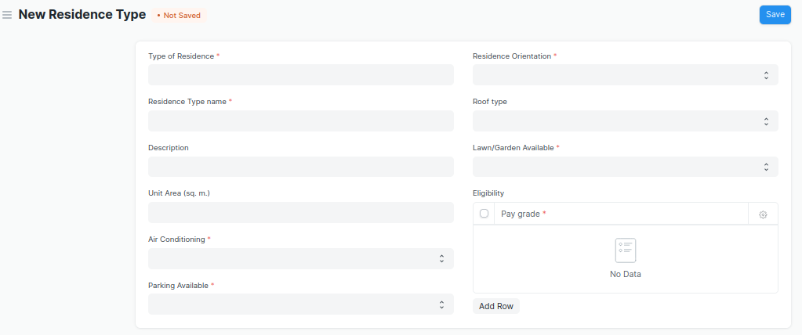

Figure 4: Residence Type

**Field List**

The **“Residence Type**” screen shall consist of the following fields:

|  |  |  |  |  |  |
| --- | --- | --- | --- | --- | --- |
| **ID** | **Field Label** | **Field Type** | **Validation/Action** | **Mandatory** | **Remarks** |
| 1 | Type of Residence | Link | Type of Residence | Y |  |
| 2 | Residence Type name | Data |  | Y |  |
| 3 | Description | Data |  |  |  |
| 4 | Unit Area (sq. m.) | Data |  |  |  |
| 5 | Air Conditioning | Drop down | Yes  No | Y |  |
| 6 | Parking Available | Drop down | Yes  No | Y |  |
| 7 | Parking Type | Drop down | On Road  Ramp Parking  Lot Parking  Garage  Shed |  |  |
| 8 | Parking Vehicle | Drop down | Two Wheeler  Four Wheeler |  |  |
| 9 | Parking Area (sq. m.) | Data |  |  |  |
| 10 | Residence Orientation | Drop down | Multi storey  One Unit Up, One Down  Side-By-Side | Y |  |
| 11 | Roof type | Drop down | Flat  Gable  Hip  Gambrel  Mansard |  |  |
| 12 | Lawn/Garden Available | Drop down | Yes  No | Y |  |
| 13 | Lawn/Garden Area (sq. m.) | Data |  |  |  |
| 14 | **Residence Eligibility** | Table |  |  |  |

|  |  |  |  |  |  |
| --- | --- | --- | --- | --- | --- |
| **Residence Eligibility** | | | | | |
| **ID** | **Field Label** | **Field Type** | **Validation/Action** | **Mandatory** | **Remarks** |
| 1 | Pay grade | Currency field |  | Y |  |

**User: Roles & Permission**

The following table describes the users and their roles and permissions for the screens:

|  |  |  |  |  |  |  |  |  |  |
| --- | --- | --- | --- | --- | --- | --- | --- | --- | --- |
| **ID** | **Role** | **Select** | **Read** | **Write** | **Create** | **Delete** | **Submit** | **Cancel** | **Amend** |
| 1 |  | Yes | Yes | Yes | Yes | Yes | NA | NA | NA |
| 2 |  | No | Yes | No | No | No | NA | NA | NA |
| 3 |  | No | Yes | No | No | No | NA | NA | NA |
| 4 |  |  |  |  |  |  |  |  |  |

## **Application for Residence**

**General Description**

|  |  |
| --- | --- |
| **Description** | **In this screen, the applicant(employee) shall apply for a residence and request the type of residence he/she wants. The operations on this screen can be performed by the applicant only.**   * **After filling up the form, the user shall click on the save button.** * **Post save user shall click on the “submit” button and application status shall appear to be “Applied”** |
| **Navigation** | Home > Infrastructure> Application for Residence |
| **Pre-requisites** |  |

**Screenshot**

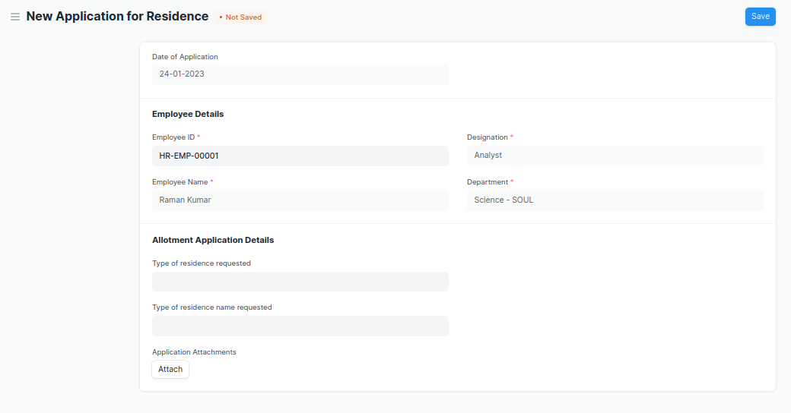

**Field List**

**The “Application for Residence” screen shall consist of the following fields:**

|  |  |  |  |
| --- | --- | --- | --- |
| **Label (Fields)** | **Type (Fields)** | **Options (Fields)** | **Mandatory** |
| Date of Application | Link |  |  |
| Application Number | Data |  |  |
| Employee Details | Data |  |  |
| Employee ID | Data | Employee | Y |
| Employee Name | Data |  | Y |
| Designation | Data |  | Y |
| Department | Data |  | Y |
| Allotment Application Details | Section Break |  |  |
| Type of residence requested | Link | Type of Residence |  |
| Type of residence name requested | Link | Residence Type |  |
| Application Attachments | Attach |  |  |
| Application Status | Data |  |  |
| Current Application Status | Data |  |  |

**User: Roles & Permission**

The following table describes the users and their roles and permissions for the screens:

|  |  |  |  |  |  |  |  |  |  |
| --- | --- | --- | --- | --- | --- | --- | --- | --- | --- |
| **ID** | **Role** | **Select** | **Read** | **Write** | **Create** | **Delete** | **Submit** | **Cancel** | **Amend** |
| 1 |  | Yes | Yes | Yes | Yes | Yes | NA | NA | NA |
| 2 |  | No | Yes | No | No | No | NA | NA | NA |
| 3 |  | No | Yes | No | No | No | NA | NA | NA |
| 4 |  |  |  |  |  |  |  |  |  |

## **Residence Allotment**

**General Description**

|  |  |
| --- | --- |
| **Description** | **This screen shall assist the Administrator to allot the vacant and not allotted residences to the applicants. The operations on this screen can be performed by the Administrator only.** |
| **Navigation** | Home > Infrastructure> Residence Allotment |
| **Pre-requisites** | **Application for residence should be in the “Applied” state.** |

* **The user shall select the application number. All the relevant details shall be fetched.**
* **The user shall select “Approved” status. The approval status field shall have the following values :**

1. **Approved**
2. **Pending**
3. **Rejected**

* **On selection of Approved, user shall fill in the fields such as Start date, End date, Building,** Residence Type, Residence Type Name, Residence number. Then the allotted residence details shall be auto fetched.
* The user shall click the Save and Submit button.
* After successful submission, the current application status of “**Application for Residence“** shall change to “Allotted”.
* On selection of either pending or rejected, the application status shall change in the “Application for Residence” screen .

**Now the user needs to give the approval status. On the basis of the selection, the user can further proceed to allotment of residence.**

**Screenshot**

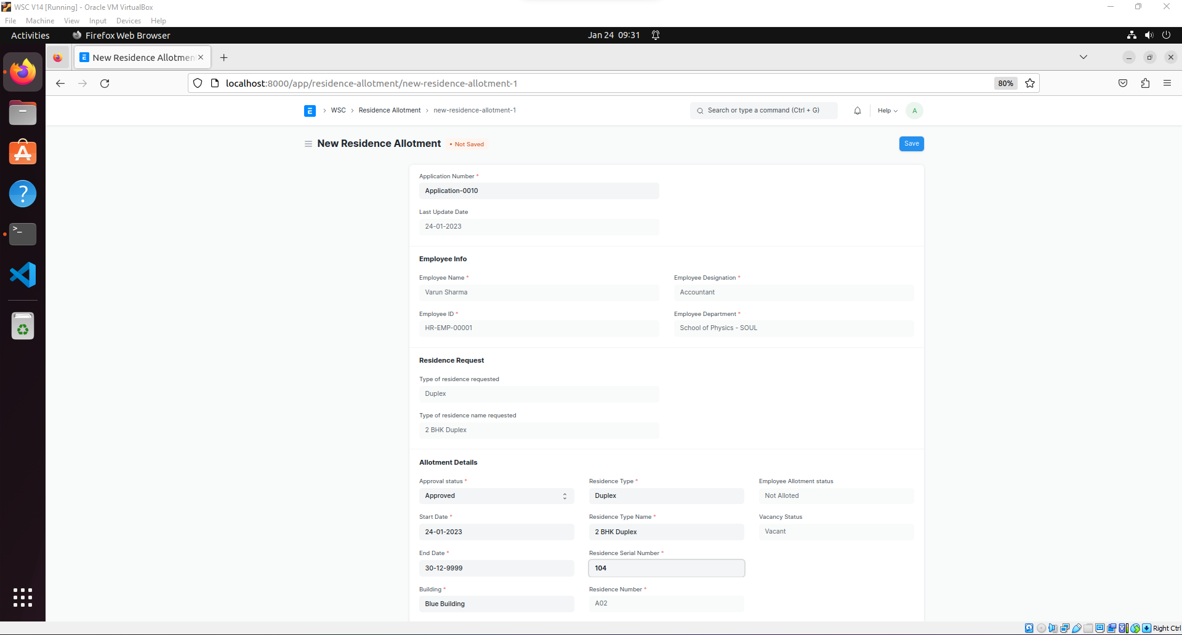

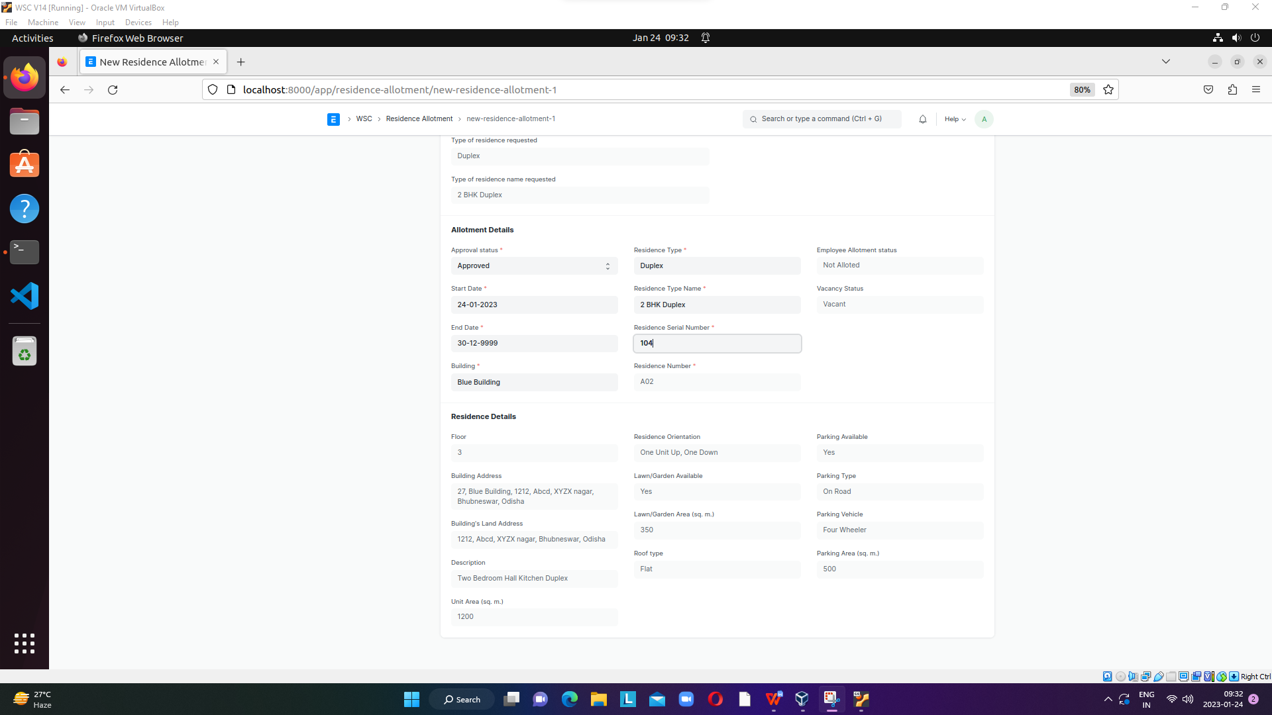

**Field List**

**The “Residence Allotment” screen shall consist of the following fields:**

|  |  |  |  |
| --- | --- | --- | --- |
| **Label (Fields)** | **Type (Fields)** | **Options (Fields)** | **Mandatory** |
| Residence Allotment Number | Link |  |  |
| Application Number | Data |  |  |
| Last Update Date | Data |  |  |
| Employee Info | Data | Employee | Y |
| Employee Name | Data |  | Y |
| Employee ID | Data |  | Y |
| Employee Designation | Data |  | Y |
| Employee Department | Data |  | Y |
| Residence Request | Section Break |  |  |
| Type of residence requested | Data |  |  |
| Type of residence name requested | Data |  |  |
| Allotment Details | Section Break |  |  |
| Approval status | Select | Approved  Pending for Approval  Rejected | Y |
| Start Date | Date |  |  |
| End Date | Date |  |  |
| Building | Link | Buildings |  |
| Residence Type | Link | Type of Residence |  |
| Residence Type Name | Link | Residence Type |  |
| Residence Serial Number | Link | Building Room |  |
| Residence Number | Data |  |  |
| Employee Allotment status | Data |  |  |
| Vacancy Status | Data |  |  |
| Current Employee Allotment status | Data |  |  |
| Current Vacancy Status | Data |  |  |
| Residence Details | Section Break |  |  |
| Floor | Data |  |  |
| Building Address | Data |  |  |
| Building's Land Address | Data |  |  |
| Description | Data |  |  |
| Unit Area (sq. m.) | Data |  |  |
| Residence Orientation | Data |  |  |
| Lawn/Garden Available | Data |  |  |
| Lawn/Garden Area (sq. m.) | Data |  |  |
| Roof type | Data |  |  |
| Parking Available | Data |  |  |
| Parking Type | Data |  |  |
| Parking Vehicle | Data |  |  |
| Parking Area (sq. m.) | Data |  |  |

**User: Roles & Permission**

The following table describes the users and their roles and permissions for the screens:

|  |  |  |  |  |  |  |  |  |  |
| --- | --- | --- | --- | --- | --- | --- | --- | --- | --- |
| **ID** | **Role** | **Select** | **Read** | **Write** | **Create** | **Delete** | **Submit** | **Cancel** | **Amend** |
| 1 |  | Yes | Yes | Yes | Yes | Yes | NA | NA | NA |
| 2 |  | No | Yes | No | No | No | NA | NA | NA |
| 3 |  | No | Yes | No | No | No | NA | NA | NA |
| 4 |  |  |  |  |  |  |  |  |  |

## **Residence Allotted (Employee Child table)**

**This child table shall reflect the residence allotment details on the employee screen.**

**On approval of residence allotment on the “Residence Allotment” screen, this child table shall be fetched on the Accommodation tab of the Employee screen.**

**Field List**

**“Residence Allotted” child screen shall consist of the following fields:**

|  |  |  |  |
| --- | --- | --- | --- |
| **Label (Fields)** | **Type (Fields)** | **Options (Fields)** | **Mandatory** |
| Residence Allotment Number | Data |  |  |
| Application Number | Data |  |  |
| Residence Type | Data |  |  |
| Residence Type Name | Data |  |  |
| Residence Number | Data |  |  |
| Floor | Data |  |  |
| Building Address | Data |  |  |
| Unit Area (sq. m.) | Data |  |  |
| Parking Available | Data |  |  |
| Parking Type | Data |  |  |
| Parking Area (sq. m.) | Data |  |  |
| Parking Vehicle | Data |  |  |
| Current Employee Allotment status | Data |  |  |

**User: Roles & Permission**

The following table describes the users and their roles and permissions for the screens:

|  |  |  |  |  |  |  |  |  |  |
| --- | --- | --- | --- | --- | --- | --- | --- | --- | --- |
| **ID** | **Role** | **Select** | **Read** | **Write** | **Create** | **Delete** | **Submit** | **Cancel** | **Amend** |
| 1 |  | Yes | Yes | Yes | Yes | Yes | NA | NA | NA |
| 2 |  | No | Yes | No | No | No | NA | NA | NA |
| 3 |  | No | Yes | No | No | No | NA | NA | NA |
| 4 |  |  |  |  |  |  |  |  |  |

## **Application for Residence De-Allottment**

**By filling out this form the applicant(employee) can apply for De-Allotment of the currently allotted residence. The operations on this screen can be performed by the applicant only.**

* **The user shall select the residence allotment number, after which all the relevant details shall be fetched.**
* **The user shall give a reason for de-allotment application.**
* **After clicking on the save and submit button, the “Current Application Status” shall change to “Applied”.**

**Screenshot**

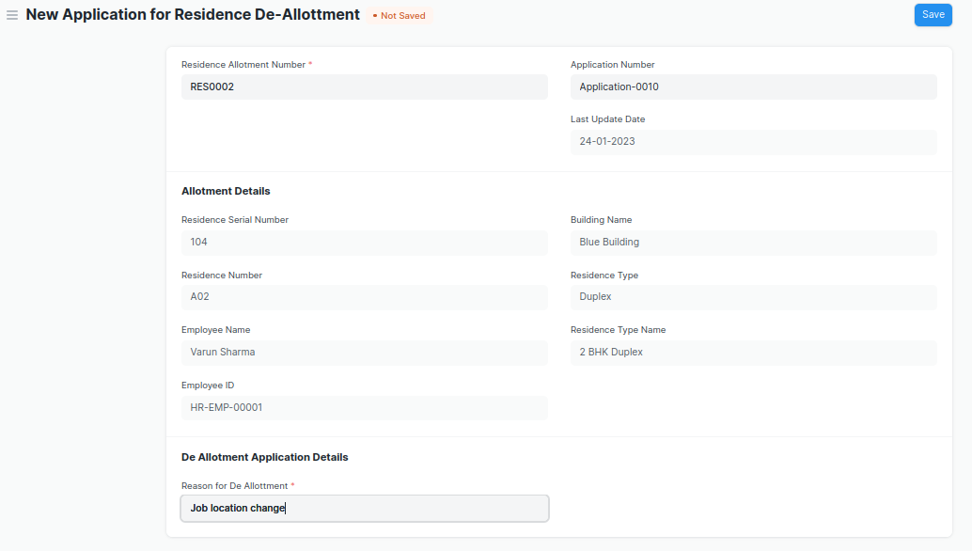

**Field List**

**The “Application for Residence De-Allotment” screen shall consist of the following fields:**

|  |  |  |  |
| --- | --- | --- | --- |
| **Label (Fields)** | **Type (Fields)** | **Options (Fields)** | **Mandatory** |
| Residence De Allotment Number | Data |  |  |
| Residence Allotment Number | Link | Residence Allotment | Y |
| Application Number | Data |  |  |
| Last Update Date | Date | Employee |  |
| Allotment Details | Section Break |  |  |
| Residence Serial Number | Data |  |  |
| Residence Number | Data |  |  |
| Employee Name | Data |  |  |
| Employee ID | Data |  |  |
| Building Name | Data |  |  |
| Residence Type | Data |  |  |
| Residence Type Name | Data |  |  |
| De Allotment Application Details | Section Break |  |  |
| Reason for De Allotment | Data |  | Y |
| Application Status | Data |  |  |
| Current Application Status | Data |  |  |

**User: Roles & Permission**

The following table describes the users and their roles and permissions for the screens:

|  |  |  |  |  |  |  |  |  |  |
| --- | --- | --- | --- | --- | --- | --- | --- | --- | --- |
| **ID** | **Role** | **Select** | **Read** | **Write** | **Create** | **Delete** | **Submit** | **Cancel** | **Amend** |
| 1 |  | Yes | Yes | Yes | Yes | Yes | NA | NA | NA |
| 2 |  | No | Yes | No | No | No | NA | NA | NA |
| 3 |  | No | Yes | No | No | No | NA | NA | NA |
| 4 |  |  |  |  |  |  |  |  |  |

## **Residence De-Allottment**

**This screen shall assist the administrator to De-allot the allotted residences to the employee and turn the status of residences to Vacant and Not Allotted. The operations on this screen can be performed by the Administrator only.**

****Pre-Requites:** Application for residence De-Allotment should be in “Applied” state.**

* **The user shall select the “**Residence De Allotment Number”, after which all the relevant details of the application shall be fetched.
* The user shall click on save and submit to confirm de-allotment.
* After successful submission the application status on “**Application for Residence De-Allottment screen” shall change to “De-alloted”.**

**Screenshot**

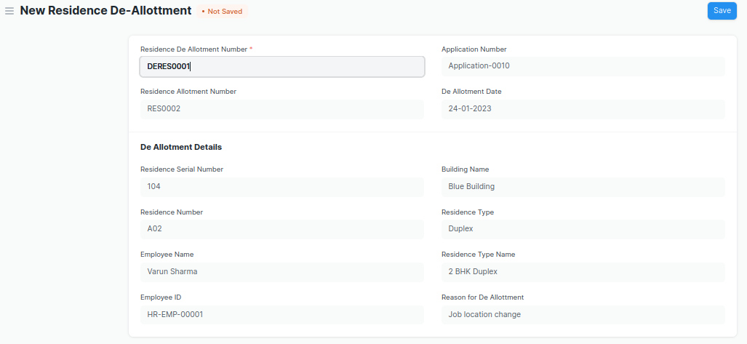

**Field List**

**“Residence De-Allottment” screen shall consist of following fields:**

|  |  |  |  |
| --- | --- | --- | --- |
| **Label (Fields)** | **Type (Fields)** | **Options (Fields)** | **Mandatory** |
| Residence De Allotment Number | Link | Application for Residence De-Allottment | Y |
| Residence Allotment Number | Data |  |  |
| Application Number | Data |  |  |
| De Allotment Date | Date |  |  |
| De Allotment Details | Section Break |  |  |
| Residence Serial Number | Data |  |  |
| Residence Number | Data |  |  |
| Employee Name | Data |  |  |
| Employee ID | Data |  |  |
| Building Name | Data |  |  |
| Residence Type | Data |  |  |
| Residence Type Name | Data |  |  |
| Reason for De Allotment | Data |  |  |

**User: Roles & Permission**

The following table describes the users and their roles and permissions for the screens:

|  |  |  |  |  |  |  |  |  |  |
| --- | --- | --- | --- | --- | --- | --- | --- | --- | --- |
| **ID** | **Role** | **Select** | **Read** | **Write** | **Create** | **Delete** | **Submit** | **Cancel** | **Amend** |
| 1 |  | Yes | Yes | Yes | Yes | Yes | NA | NA | NA |
| 2 |  | No | Yes | No | No | No | NA | NA | NA |
| 3 |  | No | Yes | No | No | No | NA | NA | NA |
| 4 |  |  |  |  |  |  |  |  |  |

## **Residence Change Request (Workflow)**

**With the help of this workflow, the applicant as well as the administration shall be able to get the residence change process done. The operations on this screen can be performed by the Administrator and the Applicant both.**

**The following are the actions which can be performed:**

****Actions by Applicant:****

1. **The applicant shall fill out the form and apply with the requested residence type and residence name**
2. **After the change request is saved and the “send for approval” button is clicked, the screen shall be accessible to the administrator.**

****Actions by Administrator:****

**Two actions can be performed by the administrator:**

1. **The administrator shall fill in the fields for “**Residence Type”, “Residence Type Name” and “Residence serial Number” and click the “approved” button. On approval, allotment and vacancy status shall be changed to vacant and not allotted for the previously allotted residence and not vacant and allotted for the newly allotted residence.
2. **“Pending for approval” or “Rejected” button which shall reflect the appropriate “Application Status” on the “Residence Change Request” screen for the applicant.**

**User: Roles & Permission**

The following table describes the users and their roles and permissions for the screens:

|  |  |  |  |  |  |  |  |  |  |
| --- | --- | --- | --- | --- | --- | --- | --- | --- | --- |
| **ID** | **Role** | **Select** | **Read** | **Write** | **Create** | **Delete** | **Submit** | **Cancel** | **Amend** |
| 1 |  | Yes | Yes | Yes | Yes | Yes | NA | NA | NA |
| 2 |  | No | Yes | No | No | No | NA | NA | NA |
| 3 |  | No | Yes | No | No | No | NA | NA | NA |
| 4 |  |  |  |  |  |  |  |  |  |

# Infrastructure Maintenance

## Asset

**General Description**

The Following table describe overall information about this screen:

|  |  |
| --- | --- |
| **Description :** | In Asset, you can maintain fixed asset records for Company assets like computers, furnitures, cars, etc. and manage their depreciations, sale, or disposal. You can track locations of the assets or keep records of employees who are using the asset. You can also manage the maintenance details of the assets. |
| **Navigation :** | Home > Material Management > Assets > Asset |
| **Pre-requisites :** | 1. Item 2. Location 3. Custodian 4. Department 5. Cost Center 6. Purchase receipt/ Purchase Invoice 7. Finance Book |

**Asset Screenshot**

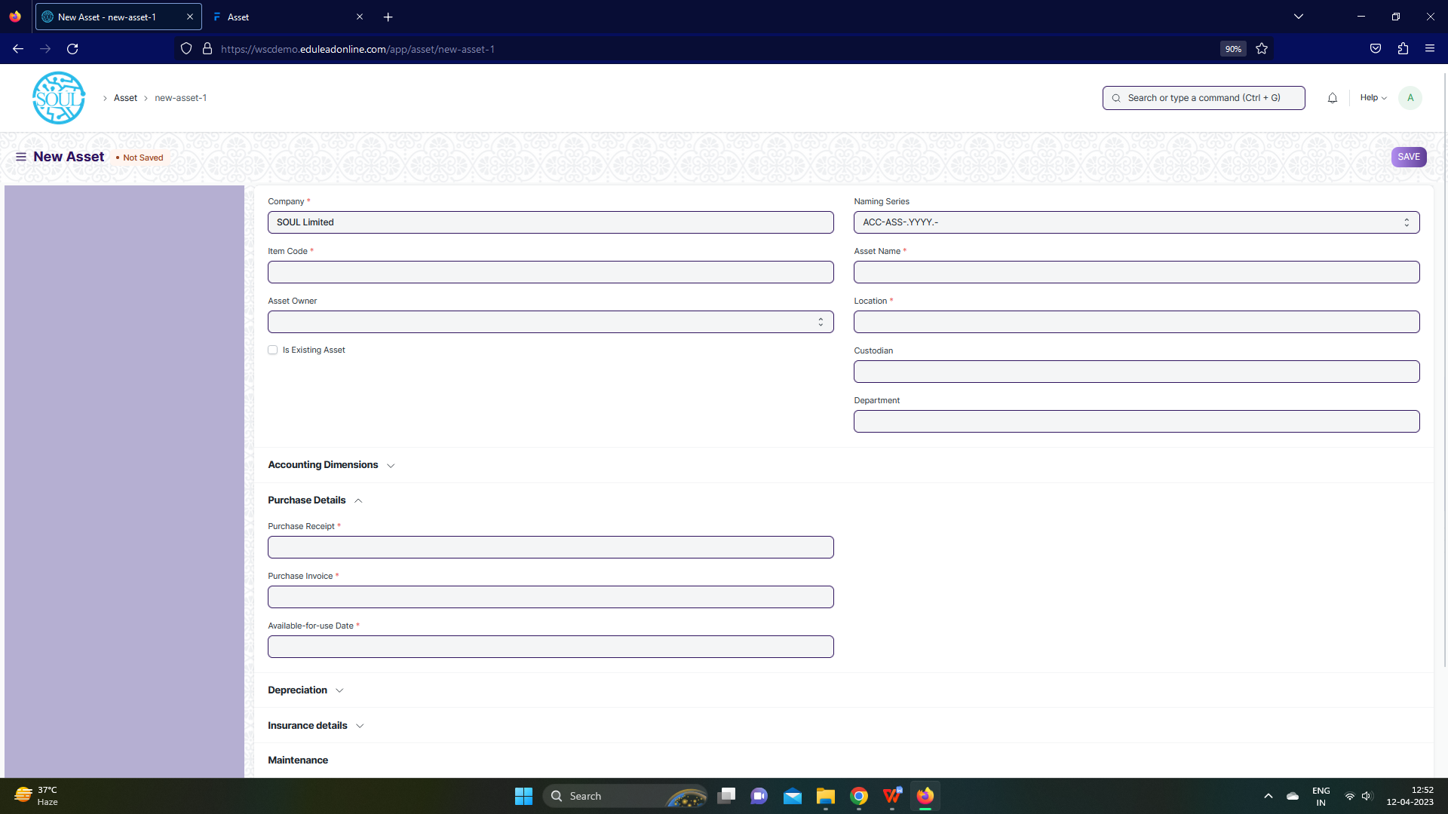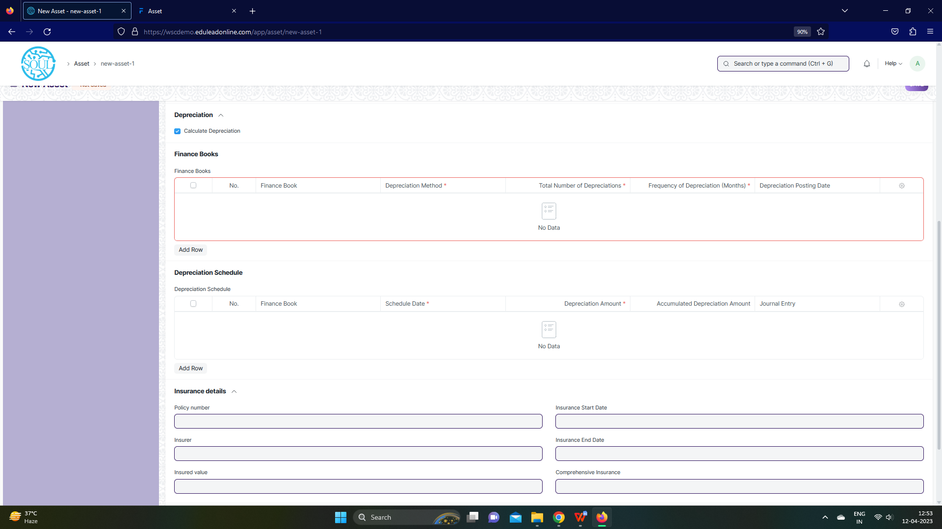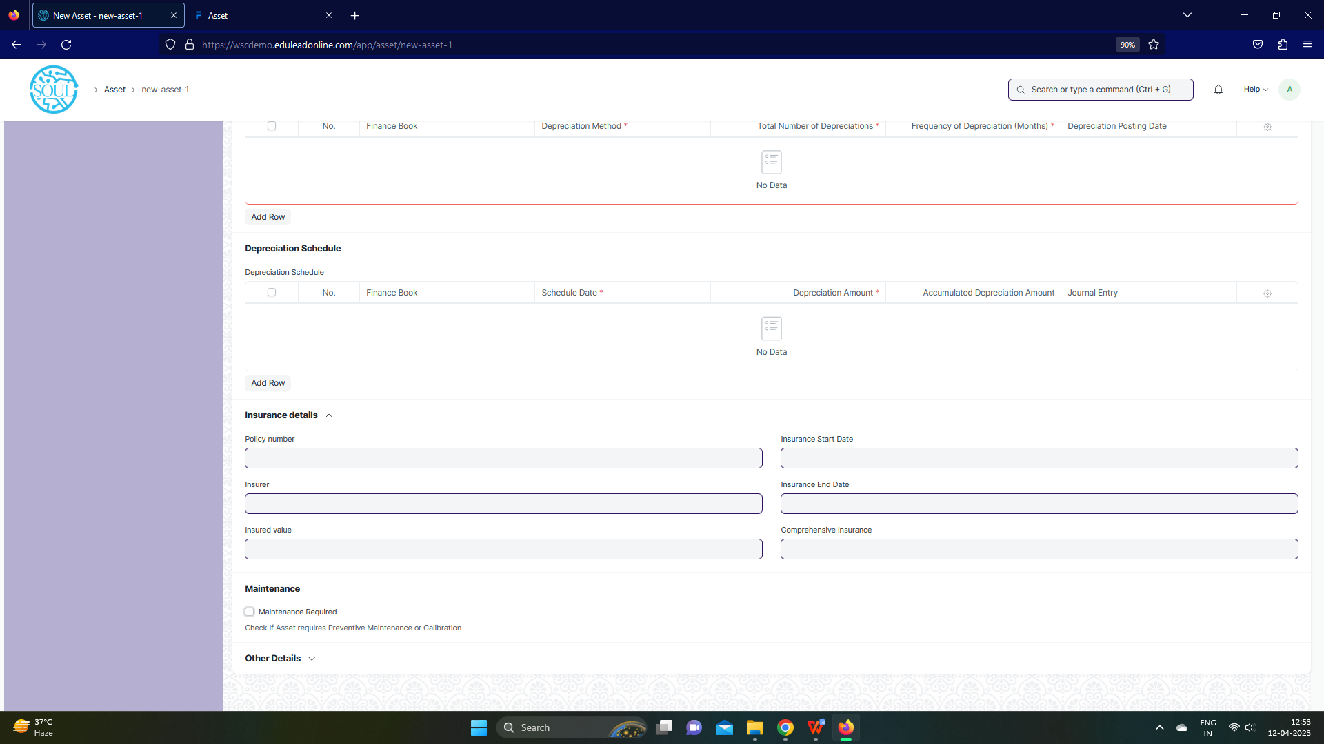

Fig: Asset Screen

**UI Fields**

The “Asset” screen shall consist of the following fields:

|  |  |  |  |  |  |  |  |  |  |
| --- | --- | --- | --- | --- | --- | --- | --- | --- | --- |
| **Field Label** | | | **Field Type** | | | **Validation/ Action** | **Mandatory** | **Remarks** | **R/N/D** |
| Company | | | Link | | | Fetched from Company screen | Yes |  |  |
| Item Code | | | Link | | | Fetched from Company screen | Yes |  |  |
| Item Name | | | Read Only | | | Populated based on selection of Item code |  |  |  |
| Asset Owner | | | Dropdown | | | Company/  Supplier /  Customer |  |  |  |
| Asset Owner Company | | | Link | | | Fetched from Company screen |  |  |  |
| Is Existing Asset | | | Checkbox | | | User Input |  |  |  |
| Supplier | | | Link | | | Fetched from Supplier screen |  |  |  |
| Customer | | | Link | | | Fetched from Customer screen |  |  |  |
| Image | | | Attach Image | | | User Input |  |  |  |
| Naming Series | | | Dropdown | | | ACC-ASS-.YYYY.- |  |  |  |
| Asset Name | | | Text Field | | | User Input | Yes |  |  |
| Asset Category | | | Link | | | Fetched from Asset Category screen |  |  |  |
| Location | | | Link | | | Fetched from Location screen | Yes |  |  |
| Custodian | | | Link | | | Fetched from Employee screen |  |  |  |
| Department | | | Link | | | Fetched from Department screen |  |  |  |
| Disposal Date | | | Date | | | User Input |  |  |  |
| Address | | | Link | | | Fetched from Address screen |  |  |  |
| Cost Center | | | Link | | | Fetched from Cost Center screen |  |  |  |
| Purchase Receipt | | | Link | | | Fetched from Purchase Invoice screen |  |  |  |
| Purchase Invoice | | | Link | | | Fetched from Purchase Invoice screen |  |  |  |
| Available-for-use Date | | | Date | | | User Input | Yes |  |  |
| Gross Purchase Amount | | | Currency | | | User Input | Yes |  |  |
| Asset Quantity | | | Int | | | User Input |  |  |  |
| Purchase Date | | | Date | | | User Input | Yes |  |  |
| Calculate Depreciation | | | Checkbox | | | User Input |  |  |  |
| Opening Accumulated Depreciation | | | Currency | | | User Input |  |  |  |
| Number of Depreciation's Booked | | | Int | | | User Input |  |  |  |
| **Finance Books** | | | **Table** | | | **These table is describe below** |  |  |  |
| Depreciation Method | | | Dropdown | | | Straight Line /  Double Declining Balance /  Manual |  |  |  |
| Value After Depreciation | | | Currency | | | User Input |  |  |  |
| Total Number of Depreciation's | | | Int | | | User Input |  |  |  |
| Frequency of Depreciation (Months) | | | Int | | | User Input |  |  |  |
| Next Depreciation Date | | | Date | | | User Input |  |  |  |
| **Depreciation Schedule** | | | **Table** | | | **These table is describe below** |  |  |  |
| Policy number | | | Text Field | | | User Input |  |  |  |
| Insurer | | | Text Field | | | User Input |  |  |  |
| Insured value | | | Text Field | | | User Input |  |  |  |
| Insurance Start Date | | | Date | | | User Input |  |  |  |
| Insurance End Date | | | Date | | | User Input |  |  |  |
| Comprehensive Insurance | | | Text Field | | | User Input |  |  |  |
| Maintenance Required | | | Checkbox | | | User Input |  |  |  |
| Status | | | Dropdown | | | Draft /  Submitted /  Partially Depreciated /  Fully Depreciated /  Sold /  Scrapped /  In Maintenance /  Out of Order /  Issue /  Receipt /  Capitalized /  Decapitalized |  |  |  |
| Booked Fixed Asset | | | Checkbox | | | User Input |  |  |  |
| Purchase Receipt Amount | | | Currency | | | User Input |  |  |  |
| Default Finance Book | | | Link | | | Fetched from Finance Book screen |  |  |  |
| Depreciation Entry Posting Status | | | Dropdown | | | Successful /  Failed |  |  |  |
| Manage | | | Button | | | Transfer Asset: On click of this button you can transfer Asset from One employee/Location to another |  |  |  |
| Scrap Asset: On click of this button you can scrap Asset |  |  |  |
| Sell Asset: On click of this button you can sell Asset |  |  |  |
| Maintain Asset: On click of this button you can create Maintenance schedule for an Asset |  |  |  |
| Repair Asset: On click of this button you can create repair details for an Asset |  |  |  |
| Split Asset: On click of this you can split Asset |  |  |  |
| Adjust Asset value: On click of this button you can see the value of Asset |  |  |  |
|  | | |  | | | View Ledger Entry: On click of this button you can view General entry for the Asset |  |  |  |
| **Finance Books (Child Table)** | | | | | | | | | |
| **Field Label** | | | | **Field Type** | | **Validation/ Action** | **Mandatory** | **Remarks** | **R/N/D** |
| Finance Book | | | | Link | | Fetched from Finance book screen |  |  |  |
| Depreciation Method | | | | Dropdown | | Straight Line /  Double Declining Balance /  Written Down Value /  Manual | Yes |  |  |
| Total Number of Depreciation | | | | Int | | User Input | Yes |  |  |
| Frequency of Depreciation (Months) | | | | Int | | User Input | Yes |  |  |
| Depreciation Posting Date | | | | Date | | User Input |  |  |  |
| Expected Value After Useful Life | | | | Currency | | User Input |  |  |  |
| Value After Depreciation | | | | Currency | | User Input |  |  |  |
| Rate of Depreciation | | | | Percent | | User Input |  |  |  |
| **Depreciation Schedule (Child Table)** | | | | | | | | |
| **Field Label** | **Field Type** | | | **Validation/ Action** | | **Mandatory** | **Remarks** | **R/N/D** |
| Finance Book | Link | | | Fetched from Finance book screen | |  |  |  |
| Schedule Date | Date | | | User Input | | Yes |  |  |
| Depreciation Amount | Currency | | | User Input | | Yes |  |  |
| Accumulated Depreciation Amount | Currency | | | User Input | |  |  |  |
| Journal Entry | Link | | | Fetched from Finance book screen | |  |  |  |
| Make Depreciation Entry | Button | | | On click of this button make depreciation entry for Asset | |  |  |  |
| Finance Book Id | Text Field | | | User Input | |  |  |  |
| Depreciation Method | DropDown | | | User Input | |  |  |  |

**Note:**

1. Asset report to be generated to differentiate between types of asset with remarks/comments
2. Stocks, Assets should be independent reports

**Users: Roles and Permissions**

The following table describes the users and their roles and permissions for the screens :

|  |  |  |  |  |  |  |  |  |  |
| --- | --- | --- | --- | --- | --- | --- | --- | --- | --- |
| **ID** | **Role** | **Select** | **Read** | **Write** | **Create** | **Delete** | **Submit** | **Cancel** | **Amend** |
|  | GM-Procurement & Contract Management | Yes | Yes | Yes | Yes | Yes | Yes | Yes | Yes |
|  | Purchase Manager | Yes | Yes | Yes | Yes | Yes | Yes | Yes | Yes |

## Asset Maintenance Team

**General Description**

The Following table describe overall information about this screen:

|  |  |
| --- | --- |
| **Description :** | The Asset Maintenance Team is responsible for carrying out maintenance activities on the Asset. |
| **Navigation :** | Home > Material Management > Maintenance> Asset Maintenance Team |
| **Pre-requisites :** | 1. User 2. Role 3. Company |

**Asset Maintenance Team Screenshot**

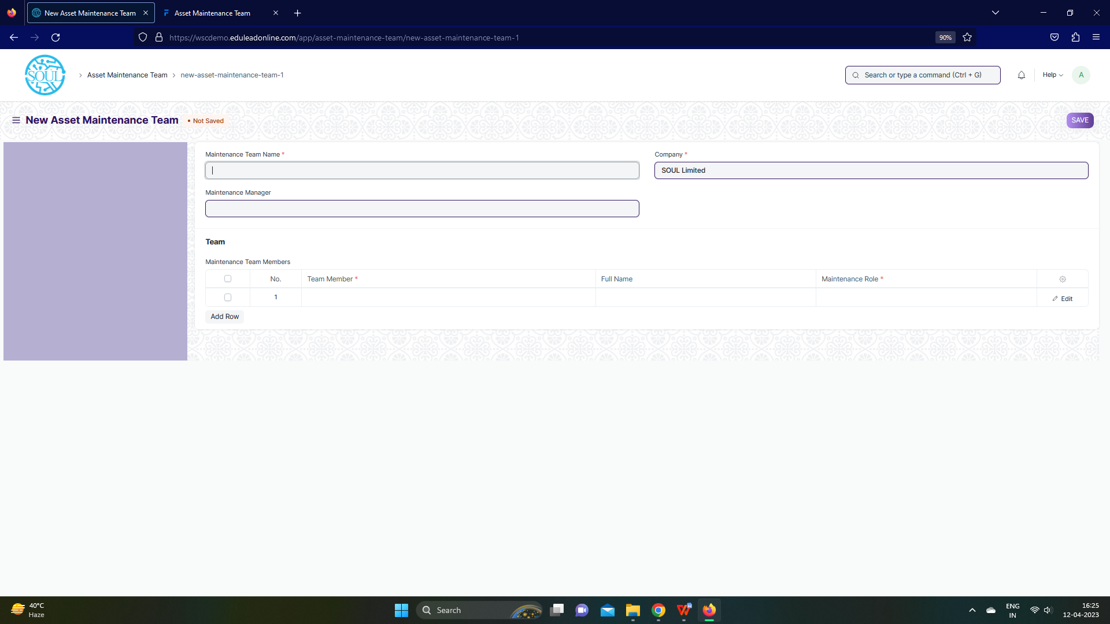

Fig: Asset Maintenance Team Screen

**UI Fields**

The “Asset Maintenance Team” screen shall consist of the following fields:

|  |  |  |  |  |  |  |
| --- | --- | --- | --- | --- | --- | --- |
| **Field Label** | **Field Type** | **Validation/ Action** | **Mandatory** | **Remarks** | **R/N/D** | |
| Maintenance Team Name | Text Field | User Input | Yes |  |  | |
| Maintenance Manager | Link | Fetched from User screen |  |  |  | |
| Maintenance Manager Name | Read Only | Fetched through Maintenance Manager |  |  |  | |
| Company | Link | Fetched from Company screen | Yes |  |  | |
| **Maintenance Team Members** | **Table** |  | Yes | These table is describe below |  | |
| **Maintenance Team Members(Child Table)** | | | | | | |
| **Field Label** | **Field Type** | **Validation/ Action** | **Mandatory** | **Remarks** | | **R/N/D** |
| Team Member | Link | Fetched from User screen | Yes |  |  | |
| Full Name | Text Field | User Input |  |  |  | |
| Maintenance Role | Link | Fetched from Role screen | Yes |  |  | |

**Users: Roles and Permissions**

The following table describes the users and their roles and permissions for the screens :

|  |  |  |  |  |  |  |  |  |  |
| --- | --- | --- | --- | --- | --- | --- | --- | --- | --- |
| **ID** | **Role** | **Select** | **Read** | **Write** | **Create** | **Delete** | **Submit** | **Cancel** | **Amend** |
|  | GM-Procurement & Contract Management | Yes | Yes | Yes | Yes | Yes | Yes | Yes | Yes |
|  | Purchase Manager | Yes | Yes | Yes | Yes | Yes | Yes | Yes | Yes |

## Asset Maintenance

**General Description**

The Following table describe overall information about this screen:

|  |  |
| --- | --- |
| **Description :** | Asset Maintenance refers to any activity done on Assets to maintain their performance or condition. |
| **Navigation :** | Home > Material Management > Maintenance> Asset Maintenance |
| **Pre-requisites :** | 1. Asset 2. Asset Maintenance Team 3. Company |

**Asset Maintenance Screenshot**

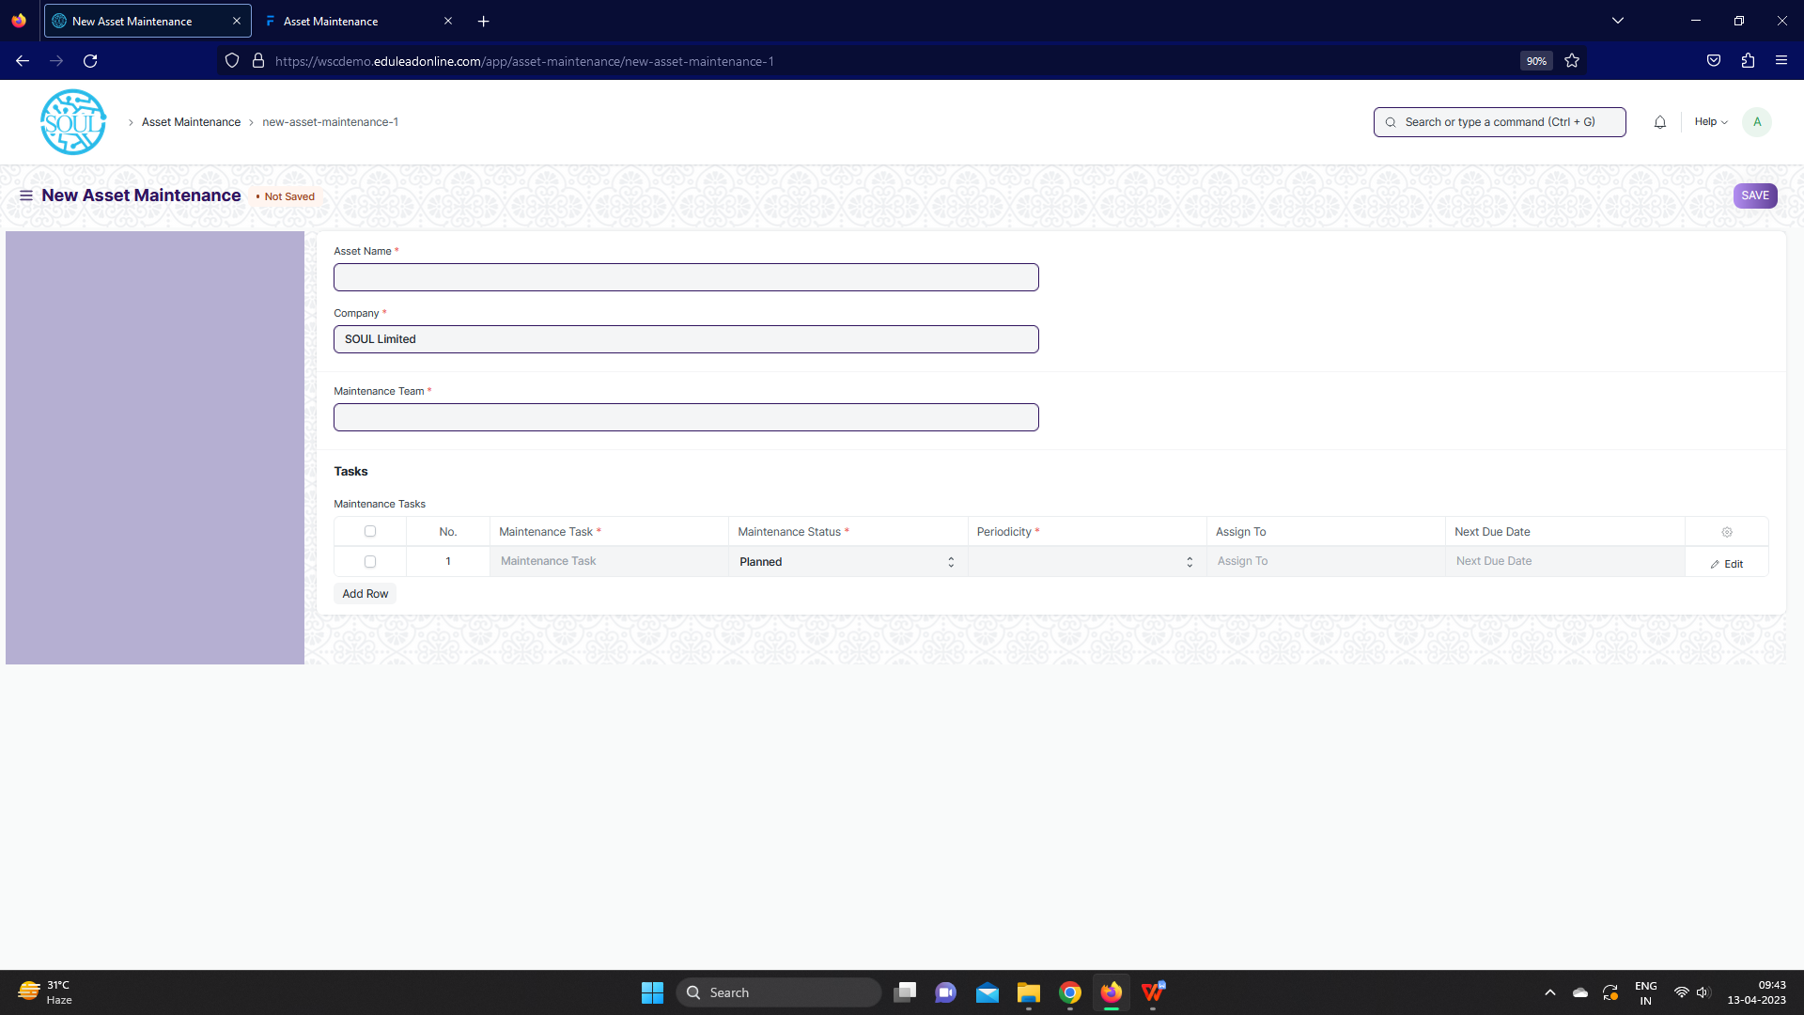

Fig: Asset Maintenance Screen

**UI Fields**

The “Asset Maintenance” screen shall consist of the following fields:

|  |  |  |  |  |  |  |
| --- | --- | --- | --- | --- | --- | --- |
| **Field Label** | **Field Type** | **Validation/ Action** | **Mandatory** | **Remarks** | | **R/N/D** |
| Asset Name | Link | Fetched from Asset screen | Yes |  | |  |
| Asset Category | Read Only | Fetched from selected asset |  |  | |  |
| Company | Link | Fetched from Company screen | Yes |  | |  |
| Item Code | Read Only | Fetched from selected asset |  |  | |  |
| Item Name | Read Only | Fetched from selected asset |  |  | |  |
| Maintenance Team | Link | Fetched from Asset Maintenance Team screen | Yes |  | |  |
| Maintenance Manager | Text Field | User Input |  |  | |  |
| Maintenance Manager Name | Read Only | Fetched from selected Asset Maintenance Team |  |  | |  |
| **Maintenance Tasks** | **Table** |  | **Yes** | These table is describe below | |  |
| **Maintenance Task (Child Table)** | | | | | | |
| **Field Label** | **Field Type** | **Validation/ Action** | | **Mandatory** | **Remarks** | **R/N/D** |
| Maintenance Task | Text Field | User Input | | Yes |  |  |
| Maintenance Type | Select | Preventive Maintenance /  Calibration | |  |  |  |
| Maintenance Status | Select | Planned / Overdue /  Canceled | | Yes |  |  |
| Start Date | Text Field | User Input | | Yes |  |  |
| Periodicity | Select | Daily / Weekly / Monthly /  Quarterly / Yearly / 2 Yearly | | Yes |  |  |
| End Date | Date | User Input | |  |  |  |
| Certificate Required | Checkbox | User Input | |  |  |  |
| Assign To | Link | Fetched from User screen | |  |  |  |
| Assign to Name | Read Only | Feted from value selected from Assign to value | |  |  |  |
| Next Due Date | Date | User Input | |  |  |  |
| Last Completion Date | Date | User Input | |  |  |  |
| Description | Text Editor | User Input | |  |  |  |

**Note:**

1. Asset Maintenance, mail to be triggered when the maintenance tasks / maintenance

log is being recorded

**Users: Roles and Permissions**

The following table describes the users and their roles and permissions for the screens :

|  |  |  |  |  |  |  |  |  |  |
| --- | --- | --- | --- | --- | --- | --- | --- | --- | --- |
| **ID** | **Role** | **Select** | **Read** | **Write** | **Create** | **Delete** | **Submit** | **Cancel** | **Amend** |
|  | GM-Procurement & Contract Management | Yes | Yes | Yes | Yes | Yes | Yes | Yes | Yes |
|  | Purchase Manager | Yes | Yes | Yes | Yes | Yes | Yes | Yes | Yes |

## Asset Maintenance Log

**General Description**

The Following table describe overall information about this screen:

|  |  |
| --- | --- |
| **Description :** | Asset Maintenance Log logs the tasks carried out in an Asset Maintenance. |
| **Navigation :** | Home > Material Management > Maintenance> Asset Maintenance Log |
| **Pre-requisites :** | 1. Asset Maintenance |

**Asset Maintenance Screenshot**

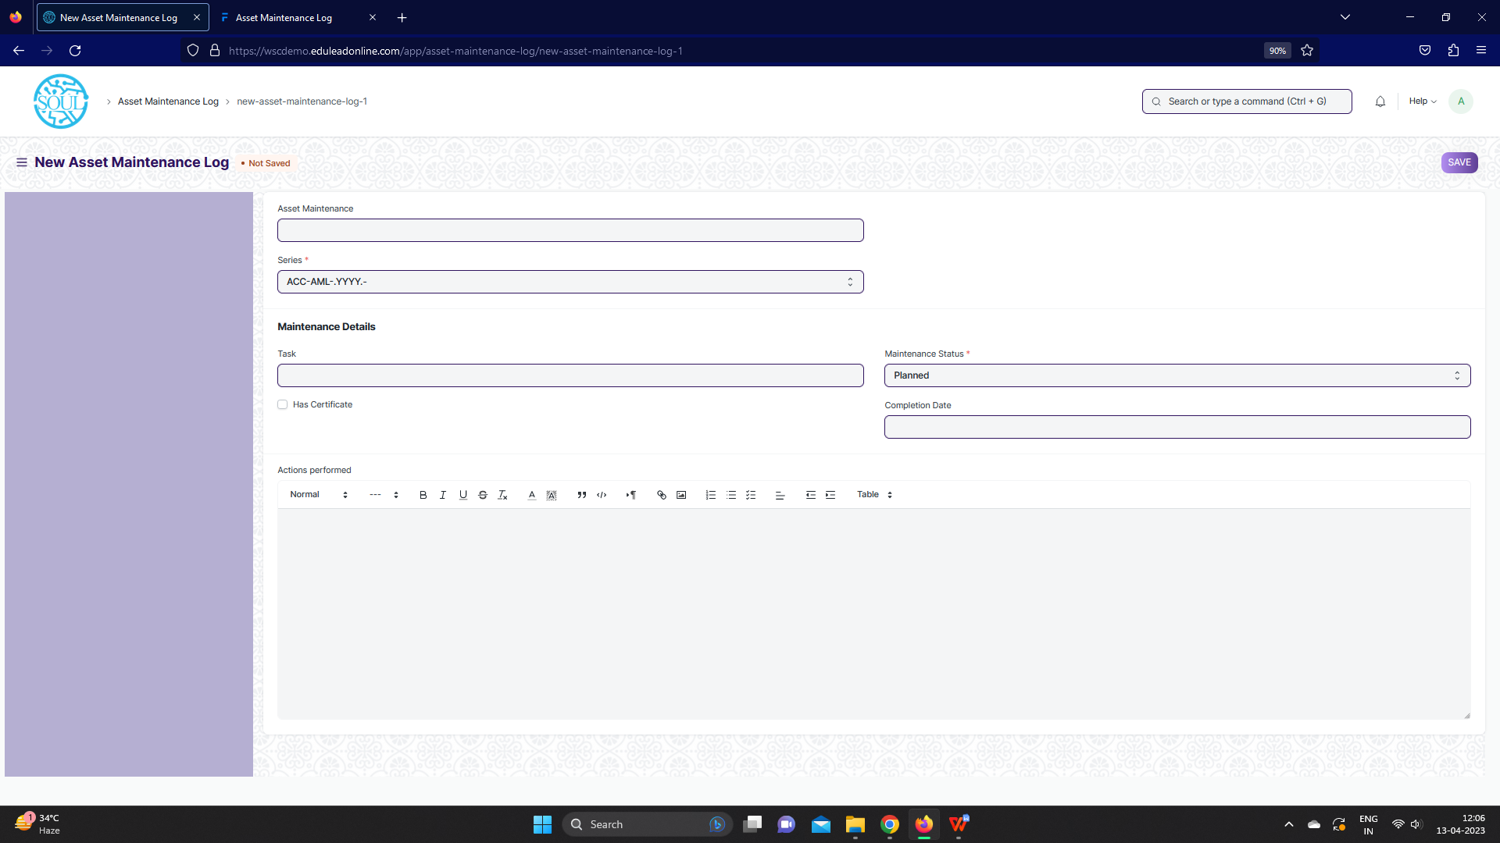

Fig: Asset Maintenance Log Screen

**UI Fields**

The “Asset Maintenance Log” screen shall consist of the following fields:

|  |  |  |  |  |  |
| --- | --- | --- | --- | --- | --- |
| **Field Label** | **Field Type** | **Validation/ Action** | **Mandatory** | **Remarks** | **R/N/D** |
| Asset Maintenance | Link | Fetched from Asset Maintenance screen |  |  |  |
| Series | Dropdown | ACC-AML-.YYYY.- | Yes |  |  |
| Asset Name | Read Only | Fetched from Asset Maintenance asset |  |  |  |
| Item Code | Read Only | Fetched from Asset Maintenance asset |  |  |  |
| Item Name | Read Only | Fetched from Asset Maintenance asset |  |  |  |
| Task | Link | Fetched from Task screen |  |  |  |
| Task Name | Text Field | User Input |  |  |  |
| Maintenance Type | Read Only | Fetched from Task asset |  |  |  |
| Periodicity | Text Field | User Input |  |  |  |
| Has Certificate | Checkbox | User Input |  |  |  |
| Certificate | Attach | User Input |  |  |  |
| Maintenance Status | Dropdown | Planned/ Completed /  Cancelled / Overdue | Yes |  |  |
| Assign To | Read Only | Fetched from Task asset |  |  |  |
| Due Date | Date | User Input |  |  |  |
| Completion Date | Date | User Input |  |  |  |
| Description | Read Only | Fetched from Task asset |  |  |  |
| Actions performed | Text Editor | User Input |  |  |  |

**Users: Roles and Permissions**

The following table describes the users and their roles and permissions for the screens :

|  |  |  |  |  |  |  |  |  |  |
| --- | --- | --- | --- | --- | --- | --- | --- | --- | --- |
| **ID** | **Role** | **Select** | **Read** | **Write** | **Create** | **Delete** | **Submit** | **Cancel** | **Amend** |
|  | GM-Procurement & Contract Management | Yes | Yes | Yes | Yes | Yes | Yes | Yes | Yes |
|  | Purchase Manager | Yes | Yes | Yes | Yes | Yes | Yes | Yes | Yes |

## Asset Repair

**General Description**

The Following table describe overall information about this screen:

|  |  |
| --- | --- |
| **Description :** | Asset Repair refers to any activity carried to repair a broken Asset to restore full functionality. |
| **Navigation :** | Home > Material Management > Maintenance> Asset Repair |
| **Pre-requisites :** | 1. Asset |

**Asset Repair Screenshot**

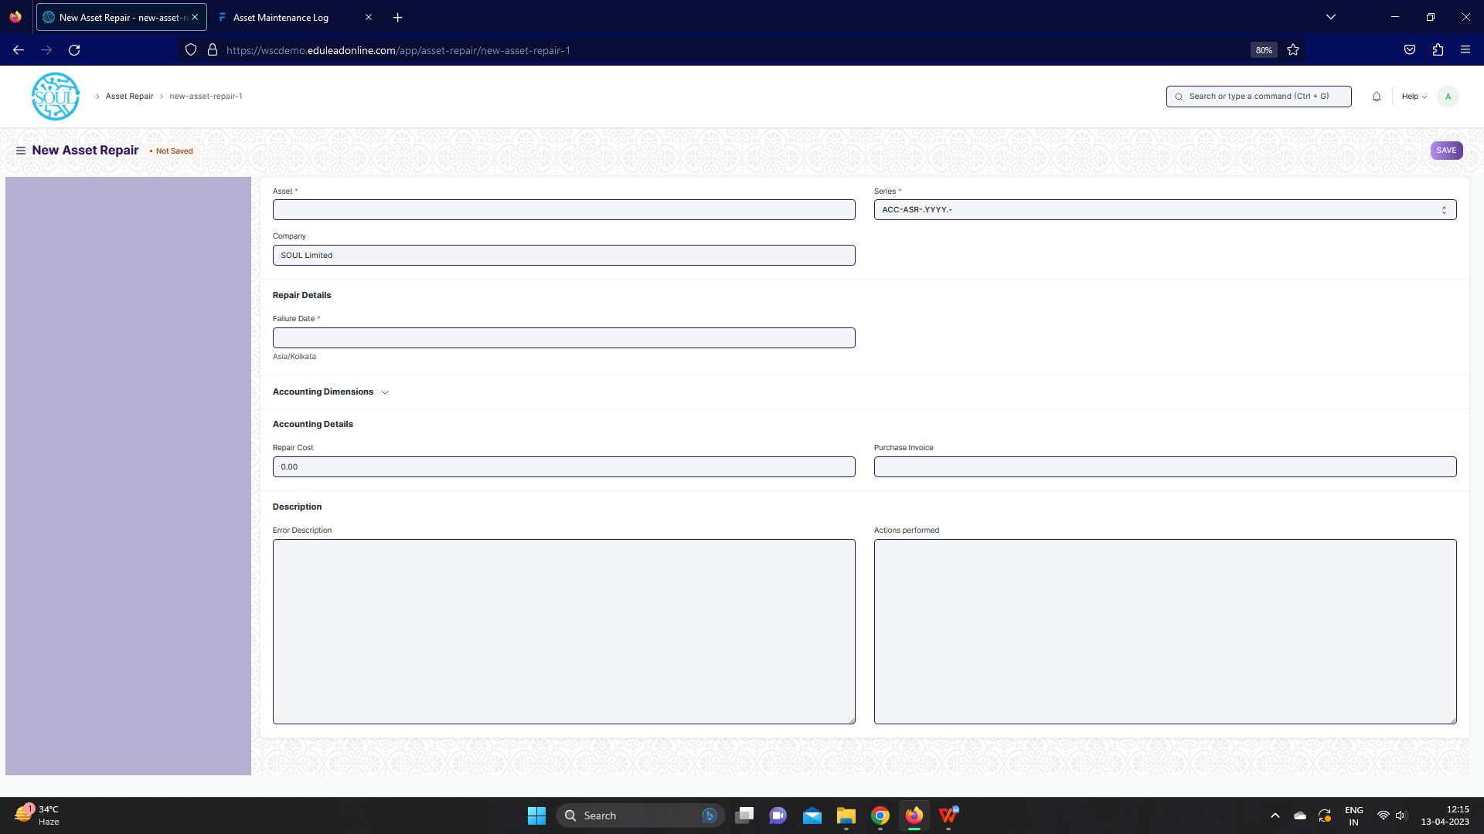

Fig: Asset Repair Screen

**UI Fields**

The “Asset Repair” screen shall consist of the following fields:

|  |  |  |  |  |  |  |  |  |  |
| --- | --- | --- | --- | --- | --- | --- | --- | --- | --- |
| **Field Label** | **Field Type** | | **Validation/ Action** | | **Mandatory** | | **Remarks** | | **R/N/D** |
| Asset | Link | | Fetched from Asset Maintenance screen | | Yes | |  | |  |
| Company | Link | | Fetched from Asset Maintenance screen | |  | |  | |  |
| Asset Name | Read Only | | Fetched from value in Asset field | |  | |  | |  |
| Series | Dropdown | | ACC-ASR-.YYYY.- | | Yes | |  | |  |
| Failure Date | Datetime | | User Input | | Yes | |  | |  |
| Repair Status | Dropdown | | Pending / ompleted /Cancelled | |  | |  | |  |
| Completion Date | Datetime | | User Input | |  | |  | |  |
| Address | Link | | Fetched from Address screen | |  | |  | |  |
| Article | Link | | Fetched from Article screen | |  | |  | |  |
| Cost Center | Link | | Fetched from Cost center screen | |  | |  | |  |
| Project | Link | | Fetched from Project screen | |  | |  | |  |
| Repair Cost | Currency | | User Input | |  | |  | |  |
| Capitalize Repair Cost | Checkbox | | User Input | |  | |  | |  |
| Stock Consumed During Repair | Checkbox | | User Input | |  | |  | |  |
| Purchase Invoice | Link | | Fetched from Purchase Invoice screen | |  | |  | |  |
| Warehouse | Link | | Fetched from Warehouse screen | |  | |  | |  |
| **Stock Items** | **Table** | |  | |  | | These table is describe below | |  |
| Total Repair Cost | Currency | | User Input | |  | |  | |  |
| Stock Entry | Link | | Fetched from Stock Entry screen | |  | |  | |  |
| Increase In Asset Life(Months) | Int | | User Input | |  | |  | |  |
| Error Description | Long Text | | User Input | |  | |  | |  |
| Actions performed | Long Text | | User Input | |  | |  | |  |
| Downtime | Text Field | | User Input | |  | |  | |  |
| View General Ledger | Button | | On click of the button you can General ledger for the Asset repair | |  | |  | |  |
| **Stock Items (Child Table)** | | | | | | | | | |
| **Field Label** | | **Field Type** | | **Validation/ Action** | | **Mandatory** | | **Remarks** | **R/N/D** |
| Item | | Link | | Fetched from Item screen | |  | |  |  |
| Valuation Rate | | Currency | | User Input | |  | |  |  |
| Consumed Quantity | | Text Field | | User Input | |  | |  |  |
| Total Value | | Currency | | User Input | |  | |  |  |
| Serial No | | Small Text | | User Input | |  | |  |  |

**Users: Roles and Permissions**

The following table describes the users and their roles and permissions for the screens :

|  |  |  |  |  |  |  |  |  |  |
| --- | --- | --- | --- | --- | --- | --- | --- | --- | --- |
| **ID** | **Role** | **Select** | **Read** | **Write** | **Create** | **Delete** | **Submit** | **Cancel** | **Amend** |
|  | GM-Procurement & Contract Management | Yes | Yes | Yes | Yes | Yes | Yes | Yes | Yes |
|  | Purchase Manager | Yes | Yes | Yes | Yes | Yes | Yes | Yes | Yes |

# Infrastructure Project Management

It will include details of hostels, new buildings, Primavera (tool currently being used), time taken to implement the project, delays and status of project, costing of the project, etc.

The Project module helps an organization to keep track of ongoing project deliverables and ensure their timely completion.

This module helps you manage your Projects by breaking them into Tasks and allocating them to different people.

Projects can be used to manage internal projects or service jobs. For service jobs, Time Sheets can also be created for billing purposes.

Purchasing can also be tracked against Projects and this can help the organisation keep tabs on its budget, delivery and profitability for a Project.

## **Project**

**General Description**

|  |  |
| --- | --- |
| **Description** | A Project is a planned piece of work that is designed to find information about something, to produce something new, or to improve something.  In this module, project management is task-driven. You can create a Project and divide it into multiple Tasks.  A Project has a broad scope and hence can be divided into tasks. Think of coming up with a new smartphone for the next year as a Project. Then things like designing, prototyping, testing, delivery, etc. become tasks under the project. |
| **Navigation** | Home > Projects > Projects > Project |
| **Pre-requisites** |  |

**Screenshot**

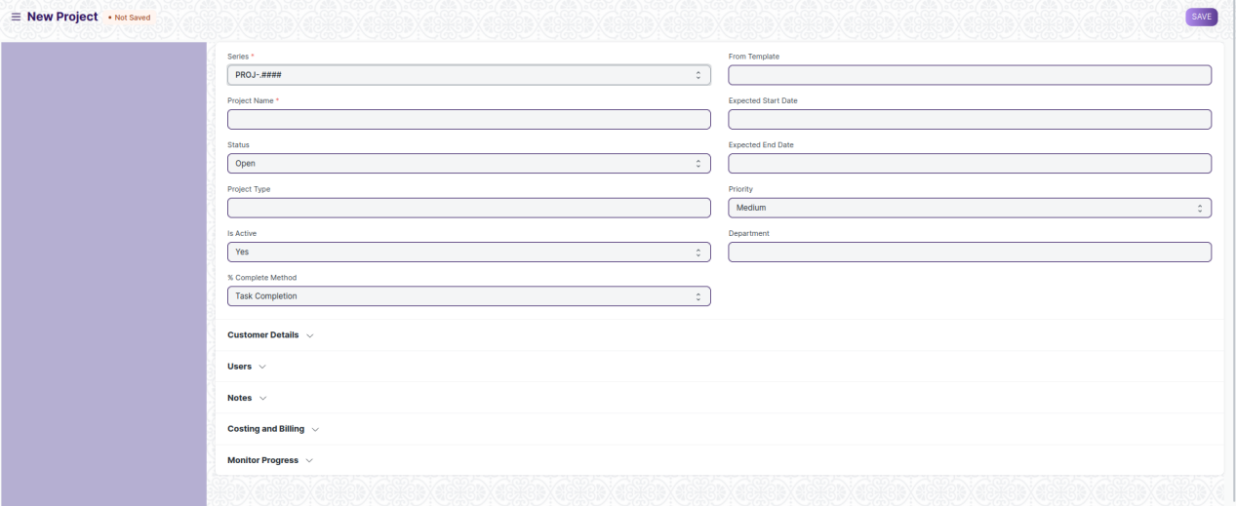

Figure 5: Project

**Field List**

The “Project” screen shall consist of the following fields:

|  |  |  |  |  |  |
| --- | --- | --- | --- | --- | --- |
| **ID** | **Field Label** | **Field Type** | **Validation/Action** | **Mandatory** | **Remarks** |
| 1 | Project Name | Text Field | User Input | Y |  |
| 2 | Status | Dropdown | Open  Completed  Cancelled |  |  |
| 3 | Project Type | Link | Fetched from Project type screen |  |  |
| 4 | Is Active | Dropdown | Yes  No |  |  |
| 5 | % Complete Method | Dropdown | Manual  Task Completion  Task Progress  Task Weight |  |  |
| 6 | % Completed | Percent |  |  |  |
| 7 | From Template | Link | Fetched from Project Template screen |  |  |
| 8 | Expected Start Date | Date picker | User Input |  |  |
| 9 | Expected End Date | Date picker | User Input |  |  |
| 10 | Priority | Dropdown | Medium  Low  High |  |  |
| 11 | Department | Link | Fetched from Department screen |  |  |
| **Customer Details** | | | | | |
| 12 | Customer | Link | Fetched from Customer screen |  |  |
| 13 | Sales Order | Link | Fetched from Sales Order screen |  |  |
| **Users** | | | | | |
| 14 | **Project User** | Table | Project User Table is described below |  |  |
| 15 | Copied From |  |  |  |  |
| **Notes** | | | | | |
| 16 | Notes | Text Editor | User Input |  |  |
| **Start and End Dates** | | | | | |
| 17 | Actual Start Date (via Time Sheet) | Date picker | User Input |  |  |
| 18 | Actual Time (in Hours via Time Sheet) | Number | User Input |  |  |
| 19 | Actual End Date (via Time Sheet) | Date picker | User Input |  |  |
| **Costing and Billing** | | | | | |
| 20 | Estimated Cost | Currency | User Input |  |  |
| 21 | Total Costing Amount (via Timesheets) | Currency | User Input |  |  |
| 22 | Total Purchase Cost (via Purchase Invoice) | Currency | User Input |  |  |
| 23 | Company | Link | Fetched from company screen |  |  |
| 24 | Total Sales Amount (via Sales Order) | Currency |  |  |  |
| 25 | Total Billable Amount (via Timesheets) | Currency |  |  |  |
| 26 | Total Billed Amount (via Sales Invoices) | Currency |  |  |  |
| 27 | Total Consumed Material Cost (via Stock Entry) | Currency |  |  |  |
| 28 | Default Cost Center | Link | Fetched from Cost Center screen |  |  |
| **Margin** | | | | | |
| 29 | Gross Margin | Currency | User Input |  |  |
| 30 | Gross Margin % | Percent | User Input |  |  |
| **Monitor Progress** | | | | | |
| 31 | Collect Progress | Check box | User Input |  |  |
| 32 | Holiday List | Link | Fetched from Holiday List screen |  |  |
| 33 | Frequency To Collect Progress | Dropdown | Hourly  Twice Daily  Daily  Weekly |  |  |
| 34 | From Time | Time picker | User Input |  |  |
| 35 | To Time | Time picker | User Input |  |  |
| 36 | First Email | Time picker | User Input |  |  |
| 37 | Second Email | Time picker | User Input |  |  |
| 38 | Daily Time to send | Time picker | User Input |  |  |
| 39 | Day to Send | Dropdown | Monday  Tuesday  Wednesday  Thursday  Friday  Saturday  Sunday |  |  |
| 40 | Weekly Time to send | Time picker | User Input |  |  |
| 41 | Message | Text Field | User Input |  |  |

|  |  |  |  |  |  |
| --- | --- | --- | --- | --- | --- |
| **Project User** | | | | | |
| **ID** | **Field Label** | **Field Type** | **Validation/Action** | **Mandatory** | **Remarks** |
| 1 | User | Link | Fetched from User screen |  |  |
| 2 | Email | Read Only | Auto fetched Based on User Field |  |  |
| 3 | Image | Read Only | Auto fetched Based on User Field |  |  |
| 4 | Full Name | Read Only | Auto fetched Based on User Field |  |  |
| 5 | Welcome email sent | Check Box | User Input |  |  |
| 6 | View attachments | Check Box | User Input |  |  |
| 7 | Project Status | Text Field |  |  |  |

**User: Roles & Permission**

The following table describes the users and their roles and permissions for the screens:

|  |  |  |  |  |  |  |  |  |  |
| --- | --- | --- | --- | --- | --- | --- | --- | --- | --- |
| **ID** | **Role** | **Select** | **Read** | **Write** | **Create** | **Delete** | **Submit** | **Cancel** | **Amend** |
| 1 |  | Yes | Yes | Yes | Yes | Yes | NA | NA | NA |
| 2 |  | No | Yes | No | No | No | NA | NA | NA |
| 3 |  | No | Yes | No | No | No | NA | NA | NA |
|  |  |  |  |  |  |  |  |  |  |

## **Task**

**General Description**

|  |  |
| --- | --- |
| **Description** | In project management, a task is an actionable unit or activity which needs to be completed. Whilst each task within a Project can be assigned to an individual or a group of individuals, the assignment can also be done at the project level.  These Tasks can be created from a Project itself or a Task can be created separately as well. |
| **Navigation** | Home > Projects > Projects > Task |
| **Pre-requisites** |  |

**Screenshot**

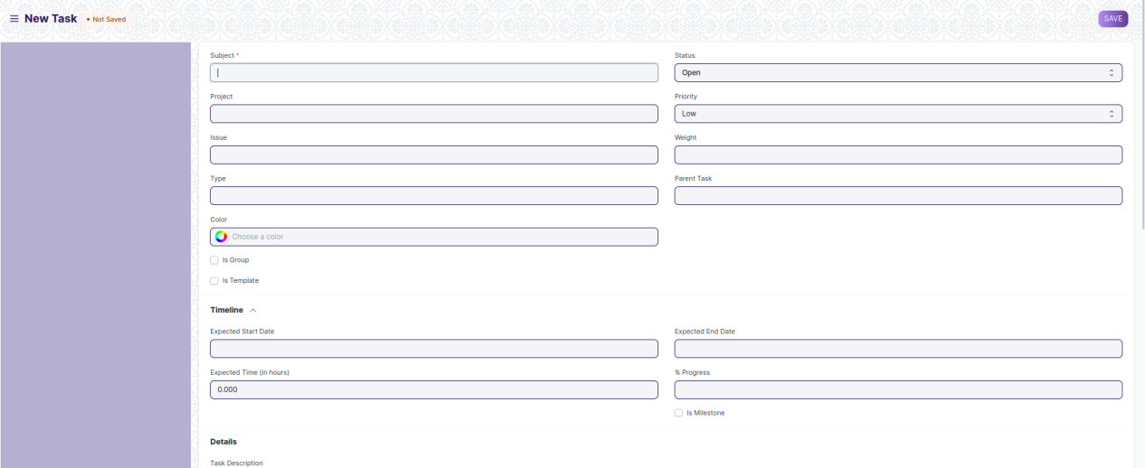

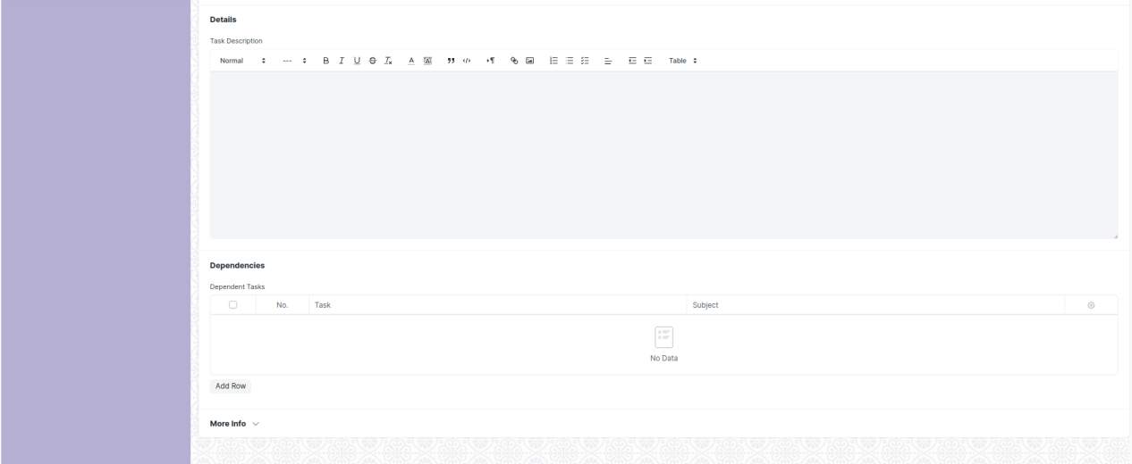

Figure 6: Task

**Field List**

The “Task” screen shall consist of the following fields:

|  |  |  |  |  |  |
| --- | --- | --- | --- | --- | --- |
| **ID** | **Field Label** | **Field Type** | **Validation/Action** | **Mandatory** | **Remarks** |
| 1 | Subject | Text Field | User Input | Y |  |
| 2 | Project | Link | Fetched from Project screen |  |  |
| 3 | Issue | Link | Fetched from Issue screen |  |  |
| 4 | Type | Link | Fetched from Task Type screen |  |  |
| 5 | Color | Color picker | User Input |  |  |
| 6 | Is Group | Check Box | User Input |  |  |
| 7 | Is Template | Check Box | User Input |  |  |
| 8 | Status | Drop down | Open  Working  Pending Review  Overdue  Template  Completed  Cancelled |  |  |
| 9 | Priority | Drop down | Low  Medium  High  Urgent |  |  |
| 10 | Weight | Number | User Input |  |  |
| 11 | Parent Task | Link | Fetched from Task screen |  |  |
| 12 | Completed By | Link | Fetched from User screen |  |  |
| 13 | Completed On | Date picker | User Input |  |  |
| **Timeline** | | | | | |
| 14 | Expected Start Date | Date picker | User Input |  |  |
| 15 | Expected Time (in hours) | Number | User Input |  |  |
| 16 | Begin On (Days) | Number | User Input |  |  |
| 17 | Expected End Date | Date picker | User Input |  |  |
| 18 | % Progress | Percent | User Input |  |  |
| 19 | Duration (Days) | Number | User Input |  |  |
| 20 | Is Milestone | Check Box | User Input |  |  |
| **Details** | | | | | |
| 21 | Task Description | Text Editor | User Input |  |  |
| **Dependencies** | | | | | |
| 22 | **Task Depends On** | Table | Task Depends On Table is described below |  |  |
| 23 | Actual Start Date (via Time Sheet) | Date picker | User Input |  |  |
| 24 | Actual Time (in Hours via Time Sheet) | Number | User Input |  |  |
| 25 | Actual End Date (via Time Sheet) | Date picker | User Input |  |  |
| **Costing** | | | | | |
| 26 | Total Costing Amount (via Time Sheet) | Currency | User Input |  |  |
| 27 | Total Billing Amount (via Time Sheet) | Currency | User Input |  |  |
| **More Info** | | | | | |
| 28 | Review Date | Date picker | User Input |  |  |
| 29 | Closing Date | Date picker | User Input |  |  |
| 30 | Department | Link | Fetched from Department screen |  |  |
| 31 | Company | Link | Fetched from Company screen |  |  |

|  |  |  |  |  |  |
| --- | --- | --- | --- | --- | --- |
| **Task Depends On** | | | | | |
| **ID** | **Field Label** | **Field Type** | **Validation/Action** | **Mandatory** | **Remarks** |
| 1 | Task | Link | Fetched from Task screen |  |  |
| 2 | Subject | Text Field | User Input |  |  |
| 3 | Project | Text Field | User Input |  |  |

**User: Roles & Permission**

The following table describes the users and their roles and permissions for the screens:

|  |  |  |  |  |  |  |  |  |  |
| --- | --- | --- | --- | --- | --- | --- | --- | --- | --- |
| **ID** | **Role** | **Select** | **Read** | **Write** | **Create** | **Delete** | **Submit** | **Cancel** | **Amend** |
| 1 |  | Yes | Yes | Yes | Yes | Yes | NA | NA | NA |
| 2 |  | No | Yes | No | No | No | NA | NA | NA |
| 3 |  | No | Yes | No | No | No | NA | NA | NA |

## **Project Template**

**General Description**

|  |  |
| --- | --- |
| **Description** | A Project Template is a predefined sequence of tasks arranged in stipulated schedule.  These templates can be pulled for similar kind of Projects and the tasks therein get auto-populated at the time of creation of each new project. |
| **Navigation** | Home > Projects > Projects > Project Template |
| **Pre-requisites** |  |

**Screenshot**

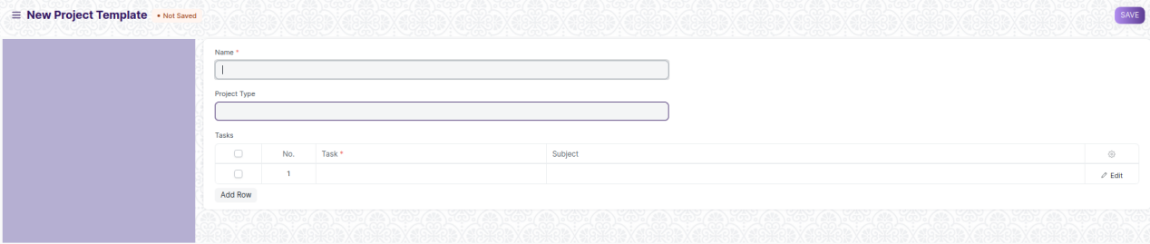

Figure 7:Project Template

**Field List**

The “Project Template” screen shall consist of the following fields:

|  |  |  |  |  |  |
| --- | --- | --- | --- | --- | --- |
| **ID** | **Field Label** | **Field Type** | **Validation/Action** | **Mandatory** | **Remarks** |
| 1 | Name | Text Field | User Input |  |  |
| 2 | Project Type | Link | Fetched from Project Type screen |  |  |
| 3 | **Project Template Task** | Table | User Input | Y |  |

|  |  |  |  |  |  |
| --- | --- | --- | --- | --- | --- |
| **Project Template Task** | | | | | |
| **ID** | **Field Label** | **Field Type** | **Validation/Action** | **Mandatory** | **Remarks** |
| 1 | Task | Link | Fetched from Task screen | Y |  |
| 2 | Subject |  | Read Only |  |  |

**User: Roles & Permission**

The following table describes the users and their roles and permissions for the screens:

|  |  |  |  |  |  |  |  |  |  |
| --- | --- | --- | --- | --- | --- | --- | --- | --- | --- |
| **ID** | **Role** | **Select** | **Read** | **Write** | **Create** | **Delete** | **Submit** | **Cancel** | **Amend** |
| 1 |  | Yes | Yes | Yes | Yes | Yes | NA | NA | NA |
| 2 |  | No | Yes | No | No | No | NA | NA | NA |
| 3 |  | No | Yes | No | No | No | NA | NA | NA |

## **Project Type**

**General Description**

|  |  |
| --- | --- |
| **Description** | A Project Type is the classification of projects into different types to group similar kind of projects.  Internal Projects, External Projects could be examples of Project types and are already created in the system. You can choose to add more Project Types. This comes handy when you are reviewing the Projects, and you want to filter the information based on Project Types. |
| **Navigation** | Home > Projects > Projects > Project Type |
| **Pre-requisites** |  |

**Screenshot**

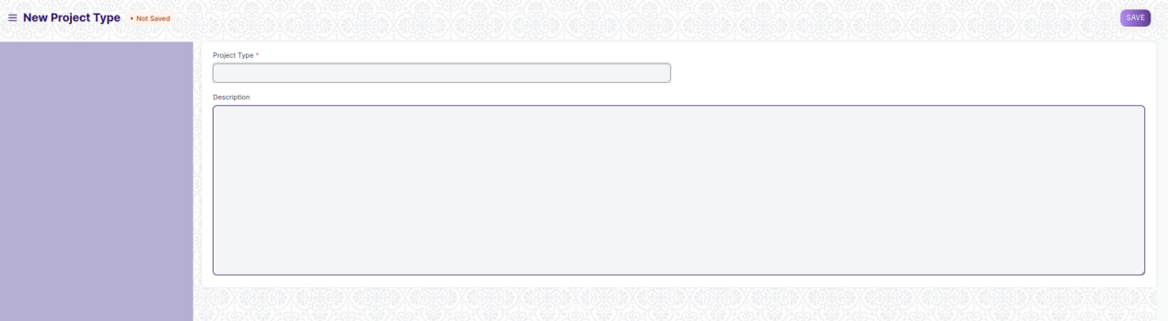

Figure 8: Project Type

**Field List**

The “Project Type” screen shall consist of the following fields:

|  |  |  |  |  |  |
| --- | --- | --- | --- | --- | --- |
| **ID** | **Field Label** | **Field Type** | **Validation/Action** | **Mandatory** | **Remarks** |
| 1 | Project Type | Text field | User Input | Y |  |
| 2 | Description | Text field | User Input |  |  |

**User: Roles & Permission**

The following table describes the users and their roles and permissions for the screens:

|  |  |  |  |  |  |  |  |  |  |
| --- | --- | --- | --- | --- | --- | --- | --- | --- | --- |
| **ID** | **Role** | **Select** | **Read** | **Write** | **Create** | **Delete** | **Submit** | **Cancel** | **Amend** |
| 1 |  | Yes | Yes | Yes | Yes | Yes | NA | NA | NA |
| 2 |  | No | Yes | No | No | No | NA | NA | NA |
| 3 |  | No | Yes | No | No | No | NA | NA | NA |

## **Project Update**

**General Description**

|  |  |
| --- | --- |
| **Description** | A Project Update is the status of the Project which can be sent to all the stakeholders of the Project.  Each time you want to update the stakeholders about the project, you can send a Project Update to them. |
| **Navigation** | Home > Projects > Projects > Project Update |
| **Pre-requisites** |  |

**Screenshot**

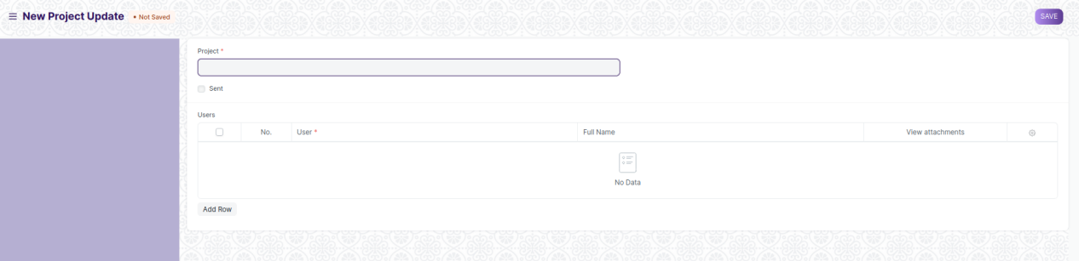

Figure 9: Project Update

**Field List**

The “Project Update” screen shall consist of the following fields:

|  |  |  |  |  |  |
| --- | --- | --- | --- | --- | --- |
| **ID** | **Field Label** | **Field Type** | **Validation/Action** | **Mandatory** | **Remarks** |
| 1 | Series | Text Field |  |  |  |
| 2 | Project | Link | Fetched from Project screen | Y |  |
| 3 | Sent | Check box | User Input |  |  |
| 4 | Date | Date picker | User Input |  |  |
| 5 | Time | Time picker | User Input |  |  |
| 6 | **Project User** | Table | Project User Table is described below |  |  |

|  |  |  |  |  |  |
| --- | --- | --- | --- | --- | --- |
| **Project User** | | | | | |
| **ID** | **Field Label** | **Field Type** | **Validation/Action** | **Mandatory** | **Remarks** |
| 1 | User | Link | Fetched from User screen |  |  |
| 2 | Email | Read Only | Auto fetched Based on User Field |  |  |
| 3 | Image | Read Only | Auto fetched Based on User Field |  |  |
| 4 | Full Name | Read Only | Auto fetched Based on User Field |  |  |
| 5 | Welcome email sent | Check Box | User Input |  |  |
| 6 | View attachments | Check Box | User Input |  |  |
| 7 | Project Status | Text Field |  |  |  |

## **Timesheet**

**General Description**

|  |  |
| --- | --- |
| **Description** | A Timesheet is the record of the number of hours spent by an employee on completion of each task. The Timesheet can also be used to calculate the billable towards an employee, to calculate their salaries, or to track an employee's contribution towards a Project or a Task.  In this module, a Timesheet can have an account of a particular employee working on multiple Tasks or Projects in a tabular format. |
| **Navigation** | Home > Projects > Time Tracking > Timesheet |
| **Pre-requisites** |  |

**Screenshot**

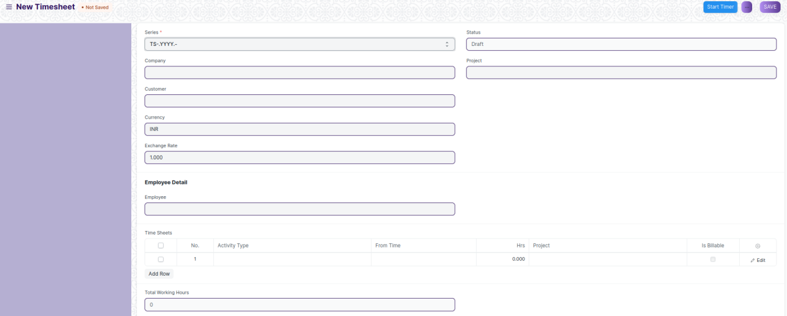

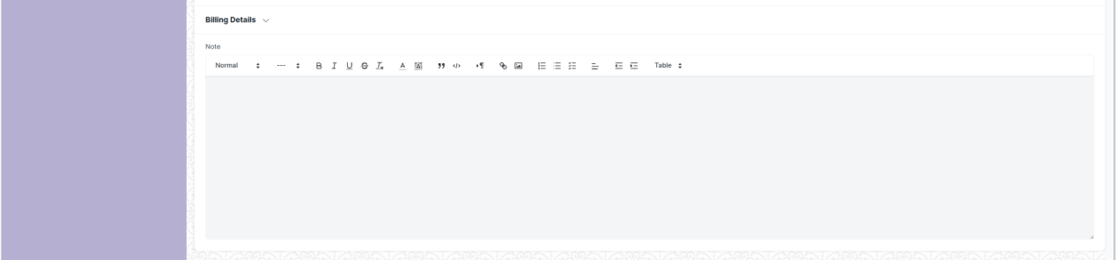

Figure 10: Timesheet

**Field List**

The “Timesheet” screen shall consist of the following fields:

|  |  |  |  |  |  |
| --- | --- | --- | --- | --- | --- |
| **ID** | **Field Label** | **Field Type** | **Validation/Action** | **Mandatory** | **Remarks** |
| 1 | Title | Text Field |  |  |  |
| 2 | Series | Drop Down | TS-.YYYY.- | Y |  |
| 3 | Company | Link | Fetched from Company screen |  |  |
| 4 | Customer | Link | Fetched from Customer screen |  |  |
| 5 | Currency | Link | Fetched from Currency screen |  |  |
| 6 | Exchange Rate | Number | User Input |  |  |
| 7 | Sales Invoice | Link | Fetched from Sales Invoice screen |  |  |
| 8 | Status | Drop Down | Draft  Submitted  Billed  Payslip  Completed  Cancelled |  |  |
| 9 | Project | Link | Fetched from Sales Project screen |  |  |
| **Employee Detail** | | | | | |
| 10 | Employee | Link | Fetched from Sales Employee screen |  |  |
| 11 | Employee Name | Text Field | Auto fetched based on Employee |  |  |
| 12 | Department | Link | Fetched from Sales Department screen |  |  |
| 13 | User | Link | Fetched from Sales User screen |  |  |
| 14 | Start Date | Date Picker | User Input |  |  |
| 15 | End Date | Date Picker | User Input |  |  |
| 16 | **Timesheet Detail** | Table | User Input | Y |  |
| 17 | Total Working Hours | Number | User Input |  |  |
| **Billing Details** | | | | | |
| 18 | Total Billable Hours | Number |  |  |  |
| 19 | Base Total Billable Amount | Currency |  |  |  |
| 20 | Base Total Billed Amount | Currency |  |  |  |
| 21 | Base Total Costing Amount | Currency |  |  |  |
| 22 | Total Billed Hours | Number |  |  |  |
| 23 | Total Billable Amount | Currency |  |  |  |
| 24 | Total Billed Amount | Currency |  |  |  |
| 25 | Total Costing Amount | Currency |  |  |  |
| 26 | % Amount Billed | Percent |  |  |  |
| 27 | Note | Text Editor | User Input |  |  |

|  |  |  |  |  |  |
| --- | --- | --- | --- | --- | --- |
| **Timesheet Detail** | | | | | |
| **ID** | **Field Label** | **Field Type** | **Validation/Action** | **Mandatory** | **Remarks** |
| 1 | Activity Type | Link | Fetched from Sales Activity Type screen |  |  |
| 2 | From Time | Datetime picker | User Input |  |  |
| 3 | Description | Text Field | User Input |  |  |
| 4 | Expected Hrs | Number | User Input |  |  |
| 5 | To Time | Datetime picker | User Input |  |  |
| 6 | Hrs | Number | User Input |  |  |
| 7 | Completed | Check Box | User Input |  |  |
| 8 | Project | Link | Fetched from Sales Project screen |  |  |
| 9 | Project Name | Text Field | Auto fetched based on Project |  |  |
| 10 | Task | Link | Fetched from Sales Task screen |  |  |
| 11 | Is Billable | Check Box | User Input |  |  |
| 12 | Sales Invoice | Link | Fetched from Sales Sales Invoice screen |  |  |
| 13 | Billing Hours | Number |  |  |  |
| 14 | Billing Rate | Currency |  |  |  |
| 15 | Billing Amount | Currency |  |  |  |
| 16 | Costing Rate | Currency |  |  |  |
| 17 | Costing Amount | Currency |  |  |  |

**User: Roles & Permission**

The following table describes the users and their roles and permissions for the screens:

|  |  |  |  |  |  |  |  |  |  |
| --- | --- | --- | --- | --- | --- | --- | --- | --- | --- |
| **ID** | **Role** | **Select** | **Read** | **Write** | **Create** | **Delete** | **Submit** | **Cancel** | **Amend** |
| 1 |  | Yes | Yes | Yes | Yes | Yes | NA | NA | NA |
| 2 |  | No | Yes | No | No | No | NA | NA | NA |
| 3 |  | No | Yes | No | No | No | NA | NA | NA |

## **Activity Type**

**General Description**

|  |  |
| --- | --- |
| **Description** | Activity Type is a list of different types of activities against which a Timesheet can be made. |
| **Navigation** | Home > Projects > Time Tracking > Activity Type |
| **Pre-requisites** |  |

**Screenshot**

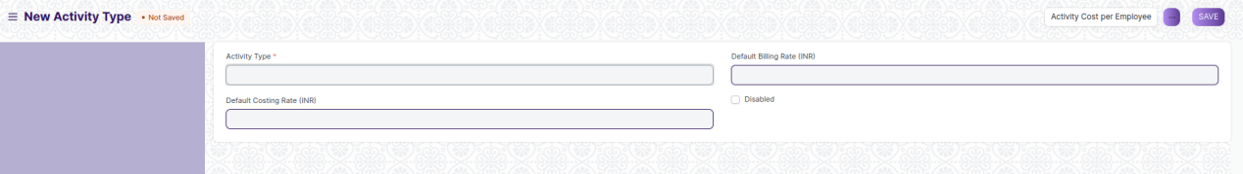

Figure 11: Activity Type

**Field List**

The “Activity Type” screen shall consist of the following fields:

|  |  |  |  |  |  |
| --- | --- | --- | --- | --- | --- |
| **ID** | **Field Label** | **Field Type** | **Validation/Action** | **Mandatory** | **Remarks** |
| 1 | Activity Type | Text Field | User Input | Y |  |
| 2 | Default Costing Rate | Currency |  |  |  |
| 3 | Default Billing Rate | Currency |  |  |  |
| 4 | Disabled | Check Box |  |  |  |

**User: Roles & Permission**

The following table describes the users and their roles and permissions for the screens:

|  |  |  |  |  |  |  |  |  |  |
| --- | --- | --- | --- | --- | --- | --- | --- | --- | --- |
| **ID** | **Role** | **Select** | **Read** | **Write** | **Create** | **Delete** | **Submit** | **Cancel** | **Amend** |
| 1 |  | Yes | Yes | Yes | Yes | Yes | NA | NA | NA |
| 2 |  | No | Yes | No | No | No | NA | NA | NA |
| 3 |  | No | Yes | No | No | No | NA | NA | NA |

## **Activity Cost**

**General Description**

|  |  |
| --- | --- |
| **Description** | Activity Cost records the per-hour billing rate and costing rate of an Employee against a particular Activity Type.  The system pulls this rate while making Timesheets. It is used to determine the Project Cost. |
| **Navigation** | Home > Projects > Time Tracking > Activity Cost |
| **Pre-requisites** |  |

**Screenshot**

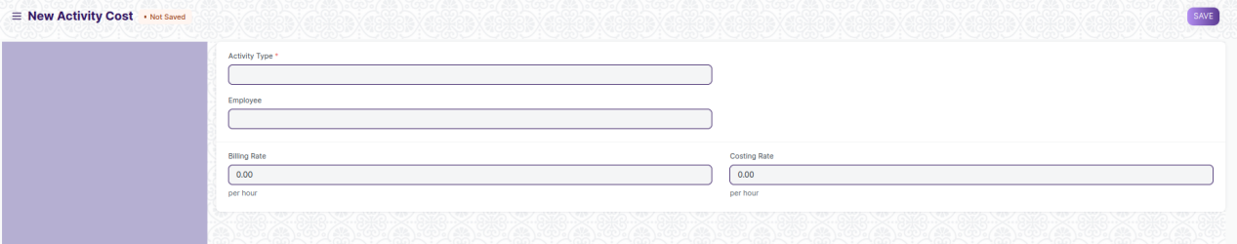

Figure 12: Activity Cost

**Field List**

The “Activity Cost” screen shall consist of the following fields:

|  |  |  |  |  |  |
| --- | --- | --- | --- | --- | --- |
| **ID** | **Field Label** | **Field Type** | **Validation/Action** | **Mandatory** | **Remarks** |
| 1 | Activity Type | Link | Fetched from Sales Activity Type screen |  |  |
| 2 | Employee | Link | Fetched from Employee Type screen |  |  |
| 3 | Employee Name | Currency | Auto fetch based on Employee |  |  |
| 4 | Department | Link | Fetched from Sales Department screen |  |  |
| 5 | Billing Rate | Currency |  |  |  |
| 6 | Costing Rate | Currency |  |  |  |

**User: Roles & Permission**

The following table describes the users and their roles and permissions for the screens:

|  |  |  |  |  |  |  |  |  |  |
| --- | --- | --- | --- | --- | --- | --- | --- | --- | --- |
| **ID** | **Role** | **Select** | **Read** | **Write** | **Create** | **Delete** | **Submit** | **Cancel** | **Amend** |
| 1 |  | Yes | Yes | Yes | Yes | Yes | NA | NA | NA |
| 2 |  | No | Yes | No | No | No | NA | NA | NA |
| 3 |  | No | Yes | No | No | No | NA | NA | NA |

**Report Screens-**

**Daily Timesheet Summary**

**Employee Hours Utilization**

**Project Profitability**

**Project wise Stock Tracking**

**Project Billing Summary**

**Delayed Tasks Summary**